

Ecological Informatics 81 (2024) 102644
Contents lists available at ScienceDirect

Ecological Informatics

journal homepage: www.elsevier.com/locate/ecolinf

Climate change effects on animal presence in the Massaciuccoli Lake basin
Gianpaolo Coro ^{a,*}, Pasquale Bove ^{b}, Ilaria Baneschi ^{b}, Andrea Bertini ^{c}, Lorenzo Calvisi ^{c},
Antonello Provenzale ^{b}
ª Istituto di Scienza e Tecnologie dell’Informazione “A. Faedo” del Consiglio Nazionale delle Ricerche (ISTI-CNR), Via Moruzzi 1, Pisa 56124, Italy
^{b} Istituto di Geoscienze e Georisorse del Consiglio Nazionale delle Ricerche (IGG-CNR), Via Moruzzi 1, Pisa 56124, Italy
^{c} University of Pisa, Lungarno Pacinotti 43, Pisa 56126, Italy

A R T I C L E I N F O

Keywords:
Ecological niche modelling Species richness
Wetlands
Artificial intelligence Open Science Maximum entropy
A B S T R A C T

Big-data mining approaches based on Artificial Intelligence models can help forecast biodiversity changes before they happen. These approaches can predict macroscopic species distribution patterns and trends that can inform preventive measures to avoid the loss of ecosystem functions and services. They can, therefore, help study and mitigate climate change implications on biodiversity conservation in fragile ecosystems. Wetlands are particu-larly fragile ecosystems where climate change poses severe risks and has dramatically reduced their size over the past century, with profound consequences on biodiversity and ecosystem services. Through big-data mining approaches, we can predict future wetland biodiversity trends in the context of climate change. This paper proposes such predictive analysis for a specific wetland: The Massaciuccoli Lake basin in Tuscany, Italy. This basin is a critical tourist attraction due to its rich biodiversity, making it an area of interest for citizens, tourists, and scientists. However, the region’s suitability for native and non-native species is at risk due to climate and land-use change. Using machine-learning models, we predict the potential effects of climate change on animal spatial distribution in the basin under different greenhouse gas emission scenarios. The results suggest that habitat suitability has generally improved from 1950 to today, presumably owing to the targeted conservation strategies adopted in the area, but climate change will severely reduce bird biodiversity by 2050 while favouring several insect species’ proliferation and other species’ habitat change, even under a medium-emission scenario. This will lead to significant changes in the basin’s biodiversity. Our methodology is adaptable to other wetland basins, being fully based on open data and models. The spatially explicit modelling used in this research provides valuable information for policymakers and spatial planners, complementing traditional biodiversity trend analyses.

Introduction

Climate change poses severe risks to delicate ecosystems such as wetlands, which have shrunk in the last decades (Creed et al., 2017; Dang et al., 2021; Gohr et al., 2021; Samal et al., 2022; Waleed et al., 2023; Xi et al., 2021) and reduced of ~70% in the twentieth century (Davidson, 2014). Consequently, there has been a severe negative impact on their biodiversity and on ecosystem services such as water quality, food and resource supply, carbon sequestration, and social and touristic features (Brink et al., 2013; Finlayson et al., 2005; Gardner and Finlayson, 2018; Gibson et al., 2015; Keddy et al., 2009). The Ramsar Convention on Wetlands has collected advice and guidance for wetland inventory, assessment, and vulnerability monitoring (Finlayson et al., 2011). The implications of global climate change on wetlands are among
the focus of the Convention and are gaining increasing attention (Barik et al., 2022; Dai, 2013; Gedney et al., 2004; Yang et al., 2017; Zhang et al., 2017). Many sites worldwide undergo poor monitoring, which prevents actions by governmental authorities to contrast degradation (Gardner and Finlayson, 2018). One crucial aspect studied in the sci-entific literature is the implication of future wetland condition changes to biodiversity conservation (Kim et al., 2023; Levandowski et al., 2021; Xi et al., 2021).
In this context, big-data mining through Artificial Intelligence models can help forecast future biodiversity change well ahead of the times (Coro et al., 2016a; Fordham et al., 2016; Trantas et al., 2023). Big data naturally contain errors and misclassifications, which might affect models’ reliability when the results are interpreted as detailed answers to the research problems. However, the results gain validity when

* Corresponding author.
E-mail address: gianpaolo.coro@isti.cnr.it (G. Coro).

https://doi.org/10.1016/j.ecoinf.2024.102644
Received 3 November 2023; Received in revised form 11 May 2024; Accepted 11 May 2024
Available online 16 May 2024
1574-9541/© 2024 The Author(s). Published by Elsevier B.V. This is an open access article under the CC BY license (http://creativecommons.org/licenses/by/4.0/).

considered as macroscopic indications rather than detailed answers (Coro et al., 2022a). Spatial analyses on extensive areas can remain valid even with a high percentage of errors in the models’ training sets (Queiroz et al., 2021). Macroscopic spatiotemporal analyses of species distributions can reveal valid and reliable properties and dynamics, providing important information for planning prevention actions and avoiding ecological degradation (Coro et al., 2022b; Pfeiffer and Ste-vens, 2015). Although these results should complement rather than substitute local-scale studies, they can provide quick overviews and answers. Several studies based on big data of wetlands have estimated that climate change can overall reduce biodiversity and create signifi-cant population shifts (Coro et al., 2016a; Desta et al., 2012). Machine learning-based approaches have forecast future biodiversity scenarios for particular species groups (e.g., plants, fishes, mammals) to assess vulnerability to climate change (Gallagher et al., 2013; Heubes et al., 2013; Thuiller et al., 2006). Other studies have predicted future area-aggregated species richness through asymptotic estimators (Chao and Chiu, 2016; Gotelli and Colwell, 2001). Data mining approaches have also used genomics-based approaches to study long-term species-rich-ness changes in wetlands (Batt et al., 2017; Gibson et al., 2015).
This paper focusses on the wetland basin of the Massaciuccoli Lake in
Tuscany (Italy) (Fig. S1), an important tourist attraction in Tuscany because of its varied biodiversity. The basin’s hydrogeological, chemi-cal, and environmental features directly influence the area’s suitability for the presence and persistence of the native species (e.g., the black bullhead, eel, tench, largemouth bass, carp, heron, kingfisher, etc.) and non-native species (e.g., sheatfish, red swamp crayfish, etc.). It is also an important hub for many bird migrations, which attract citizens’, tour-ists’, and scientists’ interest (Ciccolini et al., 2013; Nikologianni, 2019). Birds are particularly susceptible to alterations in the biogeochemical and hydrological conditions regulating the wetland’s ecosystem; there-fore, predicting these conditions’ alterations within the current climate change context is important to prevent loss of ecosystem functions that would also impact many ecosystem services (Bertacchi et al., 2015; Colombaroli and Tinner, 2013; Colombini et al., 2013; Giugliano et al., 2011).
We present a spatially-explicit, multi-species, machine-learning based animal species-richness assessment for the Massaciuccoli Lake basin. We predict overall climate change effects on animal presence in the basin under two future medium- and high-greenhouse gas emission scenarios, simulated through the Representative Concentration Path-ways (RCP) 4.5 and 8.5 (Van Vuuren et al., 2011) respectively. We es-timate species composition through models that learn from 2016 data and project potential species’ spatial distributions and richness in the future (2050 and 2100), under the two RCP scenarios. Moreover, we study how the current species composition might have changed with respect to 1999 and 1950. We combine two machine-learning models - one unsupervised and one supervised - to estimate the change of a biodiversity spatial-distribution measure (species richness) over the years in the basin, based on 180 resident species’ data. As species observation data, we use data from a public authoritative repository of big data (GBIF) improved with reliable records we accurately and directly observed in the field.
Our results highlight that climate change will pose severe risks to birds’ biodiversity, even under a medium greenhouse gas emission scenario. Climate change will also alter the distribution of aquatic and terrestrial species, which will search for cooler and water-richer areas. On the contrary, it will favour habitat suitability for several insects. The results predict that the basin’s biodiversity will significantly change, which will likely have a negative impact on ecosystem services. This scenario would call for urgent actions today to mitigate the effects of the increasing temperature and aridity trends, e.g., through water-refuelling strategies. Our results enforce the conclusions of alternative ecological studies but also add the first assessment of the timing and intensity of the change, which is valuable for management planning.
Our approach is general enough to be applied to other wetland basins
because the methodology is independent of the specific application case. In this framework, the data we use are Findable, Accessible, Interoper-able, and Reusable (FAIR). Compared to other approaches for wetland species richness estimation, we use spatially explicit modelling instead of accumulation curves (Chao and Chiu, 2016; Gotelli and Colwell,
2001; Ugland et al., 2003). Specifically, we report spatial distributions of species richness at a ∼ 50 m resolution over different years and RCP scenarios, which complement aggregated biodiversity-trend analyses
and are more practical to inform policymakers and support spatial planning (Weber et al., 2004). Previous works for the Massaciuccoli Lake basin have statistically analysed the basin-aggregated composition and trophic chain of specific species groups, e.g., macro-invertebrates (Colombini et al., 2013; Giugliano et al., 2011). A few spatially explicit analyses are available for single vegetation species related to the lake’s restoration from eutrophication (Bertacchi et al., 2015). Climate change-related studies have analysed the long-term effects of fires and vegetation change on the current vegetation biodiversity (Colombaroli et al., 2007; Colombaroli and Tinner, 2013; Lastrucci et al., 2017; Tinner et al., 2013), or probed the basin to discover the undergoing geochem-ical, hydrologic, and environmental changes (Bertacchi et al., 2019; Da Prato and Baneschi, 2020; Pistocchi et al., 2012).
The paper is organised as follows: Section 2 describes our method-
ology, including the data preparation and modelling phases and the case study. Section 3, reports the results of our species-richness analysis over the years and its evaluation. Finally, Section 4 draws the conclusions.

Methods

This section describes our approach for estimating a species-richness measure for the Massaciuccoli Lake basin in the long term. It introduces the primary data sources used for our study (Section 2.1) and the data pre-processing we applied to estimate the basin’s future environmental conditions (Section 2.2). It then explains our approach to collecting observation data from FAIR data repositories and on-the-field surveys (Section 2.3). Additionally, it illustrates a species prevalence estimation method (Section 2.4), functional to our modelling (Section 2.5). Finally, it explains our species richness estimation approach (Section 2.6) and the application to the Massaciuccoli Lake basin (Section 2.7).

  - Environmental data

The District Basin Authority of the Northern Apennines (Autorita` di bacino distrettuale dell’Appennino settentrionale) is an Italian public organisation whose role is to monitor and preserve the areas of its competence (the Central, Northern, and Western Italian Apennines) and ensure hydrogeological restoration and water resource preservation. The Authority monitors the Ligurian, Magra, Serchio, and all Tuscanian rivers (except for the Fiora river). It openly publishes topographical, urban, environmental, and territorial maps about all monitored areas. Among the open data, a few environmental parameters - crucial for agriculture and water resource management - are available for the Massaciuccoli Lake basin (Fig. 1), i.e.:

- Evapotranspiration (ET) in 2006 (mm): The combination of processes that bring water from the Earth’s surface to the atmosphere, which includes evaporation (direct movement) and transpiration (indirect movement);
- Water surplus (WS) in 2006 (mm): The amount of water from pre-cipitation exceeding evapotranspiration;
- Conductivity (C) in 2002 (S/cm): The electrical conductivity of soil and water, principally depending on salts, water capacity, nutrients, and soil texture;
- The average annual surface-air temperature (T) between 1980 and 1999 (◦C);
- The average annual precipitation (P) between 1980 and 1999 (mm).

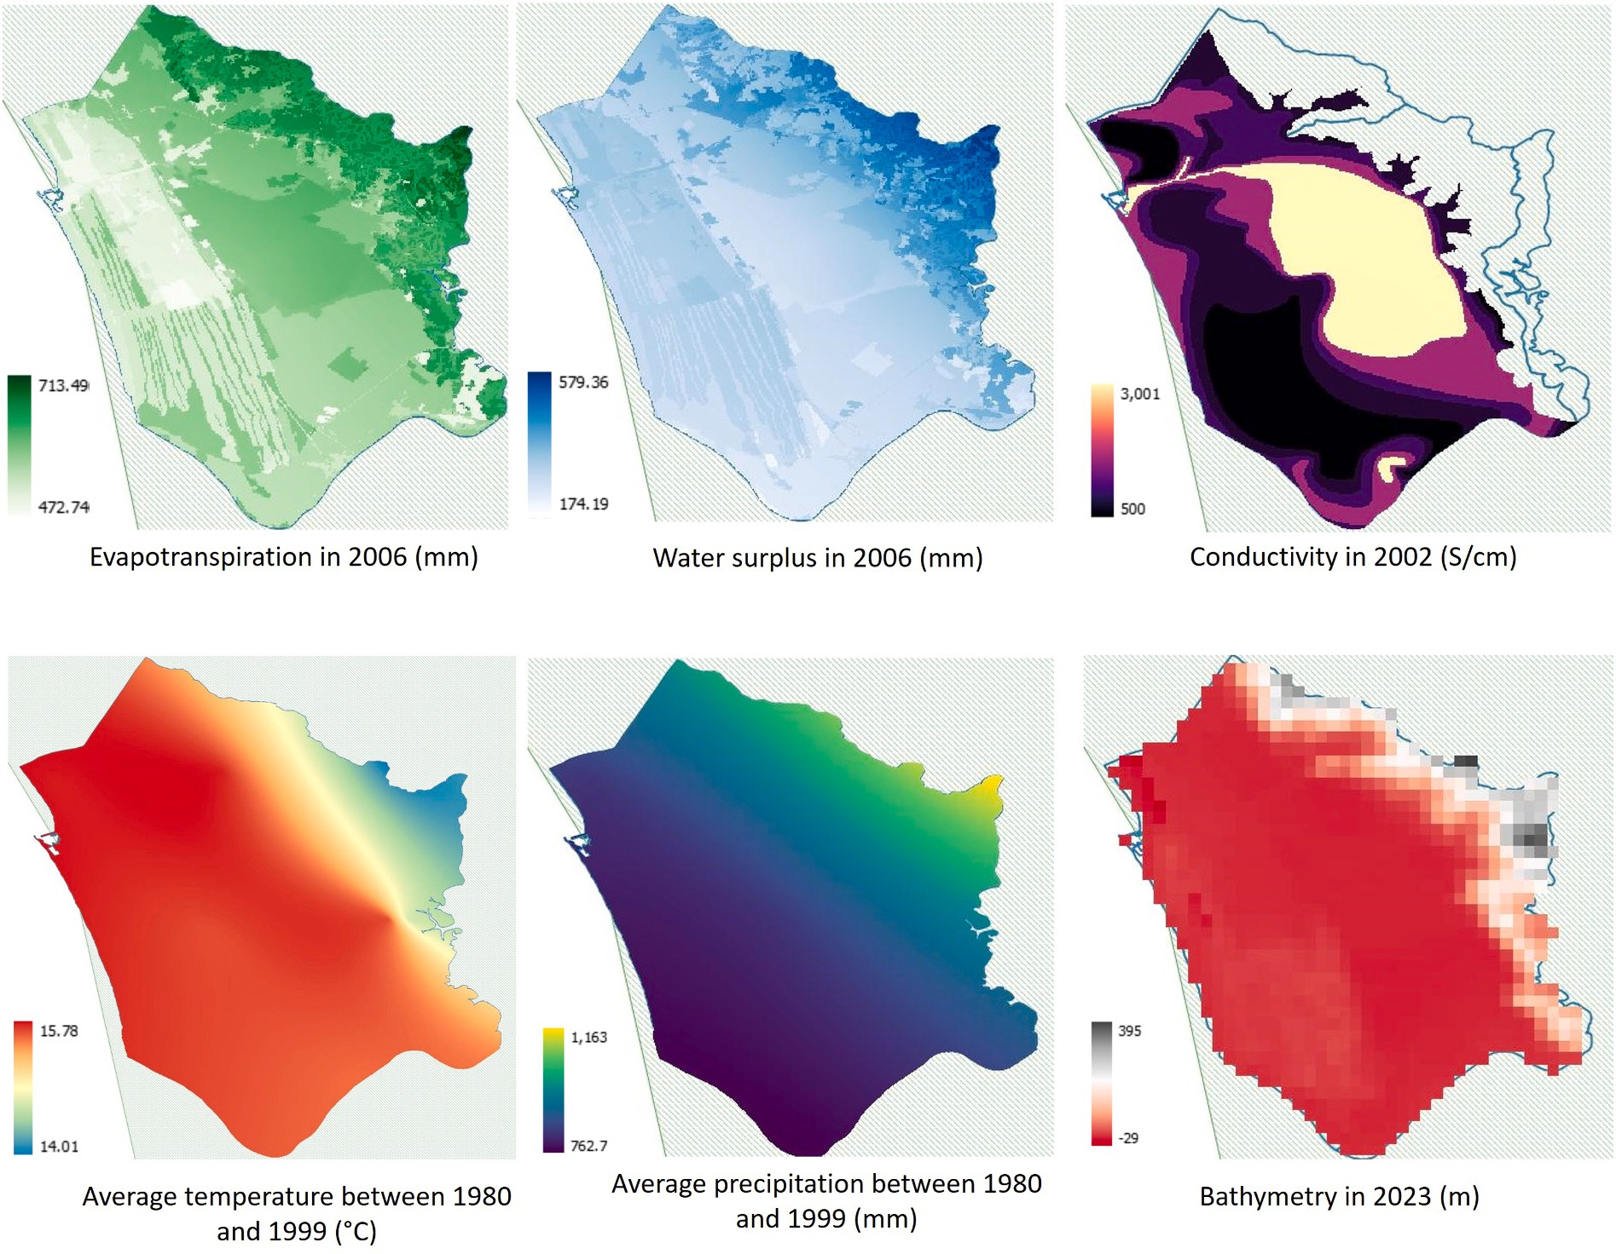

Fig. 1. Data of the District Basin Authority of the northern Appennines, downsampled at a ~ 50 km resolution (Authority data), with inner gaps for Evapotrans-piration and Water surplus filled through interpolation. The image at the lower-right corner reports altitude data from GEBCO bathymetry used for the interpolations.

We used these data for our models because they had the highest spatial resolution (~0.00005◦, i.e. ~5 m) among all data publicly available for the Massaciuccoli Lake basin. These FAIR data made our
results reproducible and repeatable. Unfortunately, the Authority data did not include additional data bringing complementary information related to biodiversity change, such as land cover and geomorphology. However, the listed parameters have demonstrated sufficient suitability for species-richness modelling in other studies and areas, also for building wetland models and species-richness temporal analyses (Coro et al., 2016a; Gohr et al., 2021; Midgley et al., 2002). Moreover, we demonstrated that they can compensate for the information brought by parameters such as bathymetry and water presence (Section 3.2). Hereafter, we will refer to them as Autority data.
Since temperature and precipitation have changed very much in the last 20 years in the Massaciuccoli Lake basin (Baneschi, 2007; Da Prato and Baneschi, 2020; Pignalosa et al., 2022a; Tinner et al., 2013), and the temporal reference in the Authority data (1980–1999) was too far from today, these data required adjustments to reflect current, near-past, and future environmental conditions (Section 2.2).

  - Environmental data re-analysis

To update the T and P data, we used past and future-projection data available from a global scale repository of FAIR environmental, geophysical, and marine-related data for ecological models (Coro et al., 2023). This repository contains surface-air temperature and precipita-tion data in the ESRI-GRID ASCII format, among its 2132 raster data of 58 parameters at regional and global scales. These data are re-analysed,
validated long-term daily forecasts between 1950 and 2100 at a 0.25◦ resolution, from the NASA Earth Exchange platform (NASA, 2020) and the Coupled Model Intercomparison Project Phase 5 (Taylor et al., 2012)
data. They result from the merge of 20 different weather models esti-mating annual temperature and precipitation values for 1950, 1999, and 2016. Forecasts for 2050 and 2100 are available under the RCP4.5 and RCP8.5 scenarios. The availability of these data and their demonstrated robustness for ecological models (Coro et al., 2023) also made the RCP environmental scenarios preferable to alternative future scenarios for our study (Nazarenko et al., 2022). We used these data in a pre-processing stage to project the Authority data in past and future sce-narios. As the first pre-processing step, we selected an appropriate spatial analysis resolution. This resolution had to be coarse enough to make statistical aggregations of species and environmental data signif-icant, and detailed enough to allow models to generate useful species-richness spatial distributions for management and planning. A reason-able choice, compliant with other regional-scale studies (Weatherall et al., 2015), was to reduce the spatial resolution of the Authority data of
one order of magnitude, i.e., to downsample them (or rasterise, in the case of C) to a ~ 0.0005◦ (~50 m) resolution. Therefore, we down-
sampled the data at this resolution and stored them as new ESRI-GRID (ASCII) files cut out on the basin boundaries (Fig. 1). Moreover, since ecological niche models should work with datasets homogeneously defined in the analysis area (i.e., without internal gaps), we used spatial interpolation to extend the definitions of ET and WS to the internal lake area, which were undefined in the Authority data. Specifically, the interpolated data estimated evaporation and water availability within the lake. We conducted interpolation through the Bayesian Interpolation

Model with Advection-diffusion Constraint (BIMAC) (Coro, 2024). BIMAC combines an iterative inverse-distance weighting interpolation method - which fills data gaps through adjacent data at each iteration - with a Bayesian model embedding hydrodynamic constraints through the advection-diffusion equation. BIMAC automatically infers all the internal model parameters by estimating the interpolated field’s spatial correlation. In the case of the Massaciuccoli Lake, we used BIMAC without lake-currents’ data (which had poor relevance). We fed the model with bathymetry data - internally used for interpolation - from GEBCO (version 2023) (Danielson et al., 2011), at a ~ 50 m resolution to comply with the target resolution.
After this pre-processing phase, we used the NASA data to project T and P in the future and the past. We took the Authority data annual average T and P between 1980 and 1999 as the projection baseline. We applied a point-by-point transformation to the baseline data by adding the per cent variation between the NASA 1999 data and the other NASA
in Section 3.2). In fact, these parameters depend on T and P non-linearly and have sensibly lower variation ranges than T and P (Aras and Celik, 2019). Specifically, since the maximum per-cell T and P variations in the considered time frame were 12.6% and 11.7%, respectively, we ex-pected a much lower variation for the other parameters. On the other hand, accurately projecting ET, WS, and C over the years would have required knowledge of weather- and area-specific parameters unavai-lable for our study. Therefore, we preferred to use only the reliable T and P projections from NASA - which correlate to ET, WS, and C variations - to produce references for future and past values. Instead, we fixed ET, WS, and C to their Authority-data values across the years and eventually evaluated the sensitivity of our results to this assumption (Section 3.2). The environmental data pre-processing algorithm can be summar-
ised as follows:
Algorithm 1. Data pre-processing.

years’ data in each point. This way, we obtained new raster data for all
projection years. Specifically, we applied the following transformation to each point (with longitude x and latitude y) of the Authority data:

A_{Y}(x, y) = A

1999
(x, y) + N_{Y}(x, y) — N₁₉₉₉(x, y) ⋅A
N₁₉₉₉(x, y)
( )

1999

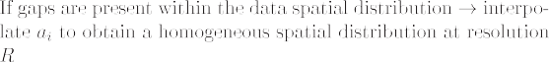
(x, y)

where A_{Y} indicates Authority data in the projection year Y, and N in-dicates NASA data. We thus obtained new data (Fig. 2) projected for 1950, 2016, 2050 under RCP4.5, 2050 under RCP8.5, 2100 under
RCP4.5, and 2100 under RCP8.5. We kept the baseline data as a proxy for the 1999 scenario.
Unfortunately, we could not project ET, WS, and C across the years and scenarios because projections were unavailable for the Massa-ciuccoli Lake basin. However, the Authority data values for these pa-rameters referred to conditions not too different from today (as verified
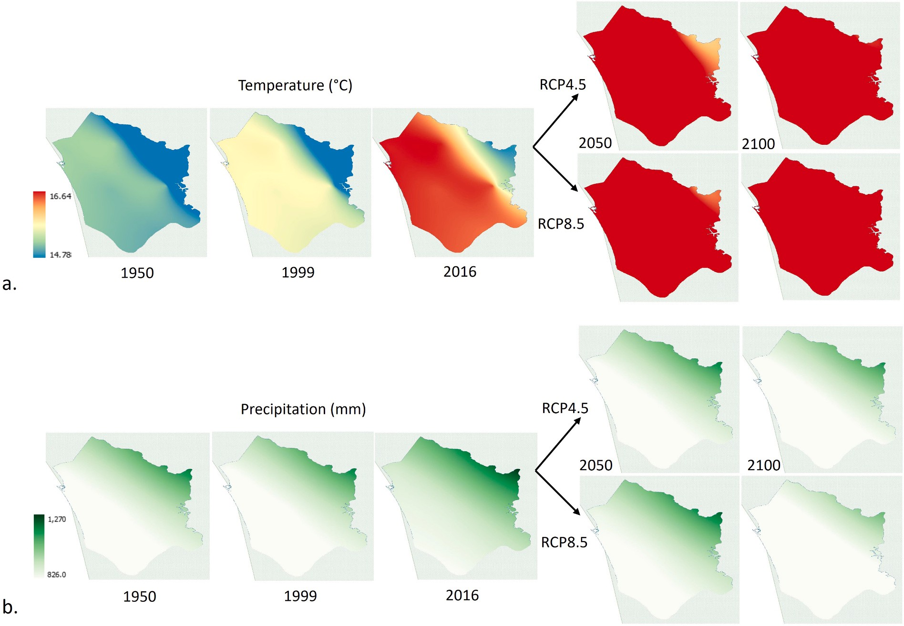

Fig. 2. Projection of Temperature (a) and Precipitation (b) data for the Massaciuccoli basin to 1950, 1999, 2016, 2050 and 2100 (under the RCP4.5 and RCP8.5 scenarios, in these two last years).

After the application of the data pre-processing algorithm, we ob-tained 17 datasets: one for ET, one for WS, one for C, 7 for T, and 7 for P. We used these data as proxy environmental conditions for annual environmental snapshots in the years 1950, 1999, 2016, 2050, and 2100 (under the RCP4.5 and 8.5 scenarios, for the last two).

  - Species observation data

Several large-scale repositories of FAIR biodiversity data are publicly available (Candela et al., 2015). Among these, the Global Biodiversity Information Facility (GBIF) (Lane and Edwards, 2007) and the Ocean Biogeographic Information System (OBIS) (Grassle, 2000) are often used in ecological and ecosystem models. Data FAIRness is guaranteed by the adoption of domain-specific standards (e.g., Darwin Core (Wieczorek et al., 2012)) and large-scale e-Infrastructures providing high-availability access services (Assante et al., 2019; Assante et al., 2022; Candela et al., 2015). These repositories include millions of records regarding species’ observations across multiple decades, allowing spe-cies presence and commonness tracking over time. However, these data should be used cautiously because they could include sampling biases - due to varying sampling efforts and paths over time and space - driving the models to overestimate or underestimate species presence (Maldo-nado et al., 2015). For example, a species might appear common in a given period and area just because there was an intensive sampling survey targeting that species in that period and area. One possibility to lower sampling bias is to combine data from FAIR repositories of species observation records with citizen-science data, i.e., data collected from the field by citizens with education on species identification. If the collection strategy had sufficient temporal and spatial precision, citizen data would allow for estimating reliable biodiversity trends, robust to errors in the overall data collection (Isaac et al., 2014). We pursued this practice for the present study.
The GBIF repository is a taxonomic and observation data provider
involved in several data FAIRness initiatives (Lane and Edwards, 2007). Unlike other data providers, GBIF has a broad scope across taxonomic orders and kingdoms. It currently hosts ~2.5 billion observation data records at the global scale. An R package is available to automatise the retrieval of occurrence records containing taxonomic, coordinate, sighting authorship, and primary source information.
As for the animals (Animalia Kingdom) living in the Massaciuccoli Lake basin, GBIF hosted 6815 geospatial-explicit records for the last ten years (2013—2023), at the time of the study (August 2023). These re-
cords corresponded to 393 different species. We used these data and
revised the species list to exclude misreported and occasional species. Given the log-normal-like distribution of the number of occurrence re-cords per species in a large basin (Coro, 2020), we selected the species with at least 5 observations because this value fell over the distribution’s second quartile and could thus be considered not-too-low. Moreover, we excluded the species not present in other Italian wetlands, which could be occasional species in the Massaciuccoli Lake basin. The resulting list contained 180 species with a total of 6540 observation records (Section Software and data availability reports the complete list). These species represented ~46% of the total reported species and were animals reli-ably living in the basin, i.e., trends valid for them could likely be generalised. Of course, other animal species have been reported as living in the basin by other studies (Marta et al., 2019), but in our study we could only rely on observations and thus could not include poorly-observed species or species without observation records associated.
The selected species belonged to animal groups such as birds (80%,
140 species), insects (15%, 30 species), and other species (reptiles, amphibians, mammals, fishes, crustaceans) (5%, 10 species) (Fig. S2). These groups accounted for 73% (birds), 22% (insects), and 100% (other species) of the total reported species in GBIF in each group. Birds were the most reported animals because of the basin’s high migration
importance, which attracts tourists and scientists in all seasons. Since we targeted annual models, we considered all-season data. We also checked this list against the GBIF-reported species for 1950 (and the previous decade) and 1999 (and the previous decade). This check confirmed that all species observed in these years were also on our last-decade list. The number of species observed in the past was notably lower (16 species for 1950 and 53 for 1999) and it was unclear if misreports were due to actual missing species or a lower frequency of the survey campaigns. Interviews with a local volunteer organisation for wildlife protection (LIPU) indicated that bird species such as Leiothrix lutea, Threskiornis aethiopicus, and Falco subbuteo - all included in our analysis - are nov-elties of the last years that have found suitable habitat in the basin. Our results agreed with these considerations and partially shed light on the issue of missing species in GBIF for past years (Section 4).
To improve the reliability of the GBIF records, we included the ob-servations of two citizens (students of the University of Pisa, co-authors of the present paper) with extensive expertise in sightseeing the native species of the basin, particularly birds, insects, fishes, and crustaceans. The students had the task to report only verified and high-confident sightings. They recorded coordinates through their smartphones’ GPS and manually adjusted the locations to improve record precision. They reported all records on a shared online MS Excel file that we eventually merged with the GBIF records. The students’ survey period was Febru-ary–September 2023. Ultimately, this citizen-science approach enriched our original GBIF occurrence-record collection with 167 new high-quality records for 43 species (already included in the GBIF species-list). In summary, our study could leverage 6707 punctual species occurrence records for 180 species, referring to the last 10 years (2013–2023), which we manually checked for consistency through the QGIS software (Moyroud and Portet, 2018). These data were the basis
for our models, alongside our re-analysed environmental data.

  - Species prevalence assessment

Although citizens’ data improved the overall quality of the occur-rence data, sub-sampling biases were likely present, primarily due to the under-representation of rare species that could drive distribution models to underestimate their presence. One way to soften this bias is to add prior information to the models, regarding species presence and commonness in the area (Sillero et al., 2021). The prior probability of a species’ presence in an area is commonly named the species’ prevalence. We approximated species’ prevalence in the Massaciuccoli Lake basin as prevalence in Italian wetlands, i.e., as the expectation that a common species in the Italian wetlands was also prevalent in the Massaciuccoli Lake basin before observing it. In a Bayesian modelling approach, such as the one we followed, this prior assumption is later revised during model’s adaptation to the data.
To estimate species commonness in Italian wetlands, we used the public wetland area definitions of the Ramsar Convention on Wetlands (available as vector geospatial data) (Finlayson et al., 2011). After that, we analysed the GBIF observations in the last decade in all Italian wetlands and classified the different types of emerging species-observation distributions. We extracted the optimal number of classes (clusters) that could be associated to these distributions through an un-supervised machine-learning model. Finally, we associated a prior prevalence value between 0.2 and 0.8 to each cluster.
As the clustering algorithm, we used a methodology that demon-strated high performance on species commonness classification (Coro et al., 2015a) (Fig. S3): First, we extracted numeric features from the observation records, which referred to species abundance (number of individuals per record), observation frequency, and habitat extension. Second, we executed the X-Means clustering algorithm (Pelleg et al., 2000), a variant of the popular K-Means algorithm that searches for the optimal assignment of the input features to different clusters, while searching for the optimal number of clusters between a minimum-maximum range. X-Means starts from the minimum cluster number and

iteratively applies K-Means until it reaches the maximum number. The optimal number of clusters corresponds to the lowest Bayesian Infor-mation Criterion (BIC) (Schwarz, 1978), which measures the overall goodness of fit of the features to the clusters. We set the cluster range of our study between 1 and 50. As the third step, after clustering, we assigned species commonness interpretations to the clusters after describing their centroids’ characteristics in natural language.
Table 2
Labels of the species commonness clusters with (i) the associated descriptions,
(ii) the prevalence values assigned, and (iii) a representative species for each cluster. Common names are reported in English and Italian, and scientific names are in parentheses.

Commonness Description Example Assigned prevalence

As numeric features, in compliance with other works (Coro et al., 2015a; Maturo, 2018), we used the ones reported in Table 1, which measure (i) the average species observation density within the presence
areas, (ii) species presence and overall abundance across the areas, (iii)
High Abundant in most areas, widespread, and frequently observed across many wetlands
Eurasian coot/Folaga (Fulica atra)
0.8

the relative number of areas in which a species is present, (iv) the widespreadness of a species in the presence areas, (v) the observation frequency, and (vi) how much a species is observed with a high fre-
quency (at least five occurrences per year). These features describe
Medium-High
Abundant in several areas, averagely widespread, and frequently observed across several wetlands
Great tit/Cinciallegra (Parus major)
0.7

common species in wetlands as frequent, widespread, and abundant species. Conversely, they describe rare species as localised, infrequent, and only present in a few wetlands.
Since prevalence assessment was a fundamental pre-processing step for our modelling approach design, we report the findings already here: The X-Means algorithm indicated the existence of six optimal clusters, similarly to other studies (Coro et al., 2015a). The natural-language descriptions of the cluster centroids’ features allowed us to assign overall species-commonness labels between High and Very Low to the clusters (Table 2). Consequently, we assigned a prevalence score be-tween 0.2 and 0.8 to each interpreted cluster. The species with Medium/ Medium-Low/Medium-High commonness constituted the largest set, overall accounting for 72% of all species (Fig. S3). Highly-common species constituted the 7% and Low/Very Low species the 21%.
Medium Averagely abundant and observed with moderate frequency in several wetlands
Medium-Low Poorly abundant and
unfrequently observed, but seen in several wetlands
Low Poorly abundant, localised, and unfrequently observed

Very low Poorly abundant, localised, present in few wetlands, and rarely observed
Pintail/Codone (Anas acuta)

Dunnock/Passera scopaiola (Prunella modularis)

Hummingbird hawk-moth/Sfinge colibrì (Macroglossum stellatarum)
Red avadavat/ Bengalino moscato (Amandava amandava)
0.5

0.4

0.3

0.2

  - Ecological niche modelling

Ecological niche models (ENMs) estimate the set of resources and environmental conditions underlying the suitability of an area to a species’ presence, i.e., the species’ fundamental ecological niche (Campos et al., 2023; Coro et al., 2016a; Deneu et al., 2021; Jones et al., 2012; Pearson, 2007; Weber et al., 2017). ENMs estimate a species’ habitat as the regions with environmental conditions falling within the species’ ecological niche. An ENM for a species’ native areal estimates the actual (or native) species’ distribution. Outside of the native area, the ENM estimates the potential (or suitable) species’ distribution (Anderson et al., 2011; Peterson and Sobero´n, 2012). Mathematically, a species’ ecolog-ical niche is defined within a vector space whose dimensions are envi-ronmental parameters. The model’s task is to trace a hypervolume within the vector space associated with the species’ subsistence conditions. The ENM performance in correctly tracing the species’ preferences depends
on identifying a complete set of environmental parameters related to the species’ subsistence (Pearson, 2007). Therefore, parameter selection methods are often used before ENMs (Bargain et al., 2017; Coro et al., 2013a; Coro et al., 2015b; Coro et al., 2015c; Guo and Liu, 2010; Magliozzi et al., 2019; Muscarella et al., 2014; Sa´nchez-Tapia et al., 2017; Schnase et al., 2021; Warren and Seifert, 2011; Zeng et al., 2016). ENMs use statistical analysis, machine learning, or expert-defined rules to estimate the species’ ecological niche as a predictive function be-tween habitat suitability conditions and the input environmental pa-rameters. One input to an ENM is, therefore, a set of environmental parameters related to species’ subsistence in the analysis area, homo-geneously defined on the area at a specific spatial resolution (Alvera-Azca´rate et al., 2005; Durand et al., 2010; Huang et al., 2008; Peterson, 2001; Ravdas et al., 2018; Scarponi et al., 2018; Werdell and Bailey, 2005). An additional input is a set of species observations in the area (presence locations) and, possibly, locations where habitat is known to be unsuitable (absence locations) or random places potentially representing

Table 1
Definition of the numeric features extracted from our species observation data to describe species commonness-related characteristics.
Feature name Description Analytic definition

Abundance Average density of occurrence records

A = ∑All areas
No. occurrences area extent

No. areas
∑
Intra-area commonness Average number of occurrence records across the areas Intra = All areas No. occurrences No. areas
Inter-area commonness Fraction of areas where the species has been observed Inter = No. areas with occurrences
No. areas

Observation extent Average fraction of occurrence cells at 0.1◦ resolution with occurrence records
associated E =
∑All areas with occurrences
No. cells with occurrences
No. cells

Observation frequency Average annual frequency of observation
No. areas with occurrences
∑ No. years with occurrences
No. years
All areas with occurrences

High-observation frequency

Average annual frequency of many observations
=

Fthr =
F
∑
All areas with occurrences
No. areas with occurrences

No. years with occurrences > 5
No. years

No. areas with occurrences

averagely unsuitable conditions (background locations) (Campos et al., 2023; Coro et al., 2016b; Elith et al., 2011a). Bayesian ENMs also require specifying the prior probability of species presence (i.e., the prevalence), which they revise through likelihood adaptation to produce a posterior probability of habitat suitability (Sillero et al., 2021).
Operationally, a species’ ENM can calculate the probability that a specific location, defined through its environmental features, is a suit-able habitat for the species. The ENM thus predicts habitat suitability probability in all locations within a study area data or under future climatic scenarios (Ashraf et al., 2017; Chala et al., 2019; Coro, 2020; Coro et al., 2016a; Coro et al., 2018; Coro et al., 2022c; Friedlaender et al., 2011; Lasram et al., 2010; Peterson et al., 2007).
For the present study, we used the Maximum Entropy (MaxEnt) ENM, a shallow-machine learning model that can reach high prediction accuracy (Angeletti et al., 2020; Baldwin, 2009; Capezzuto et al., 2018; Coro et al., 2015b; Coro et al., 2022b; Coro and Bove, 2022; Phillips et al., 2004; Phillips et al., 2006; Phillips and Dudik, 2008). MaxEnt can be effective in estimating species-richness change under future climate change conditions using regional- or global-scale environmental pa-rameters (Coro et al., 2022a; Gallagher et al., 2013; Xu et al., 2012). The model builds a species’ ecological niche as a probability density function
π(x) of habitat suitability in the vector space of environmental param-
eters x. It uses two constraints: (i) π(x) should assign a reasonably high probability to the mean parameter values at the presence locations and
∑
(ii) the overall entropy function (H = — π(x) ln(π(x) )) should be maximum (Elith et al., 2011b; Merow et al., 2013; Phillips and Dudík, 2008). During training, MaxEnt maximises the entropy function on the
species presence locations with respect to the entropy function on background locations (Phillips et al., 2006). Alternatively, absence lo-cations can be provided if available. At the end of the entropy max-imisation process, π(x) will model a projection function that can be used
to estimate species’ habitat suitability on an area at the environmental
parameters’ spatial resolution (R), i.e. on all the squares with side-size R (cells) covering the area (Coro et al., 2018; Pearson, 2007).
One advantage of MaxEnt with respect to alternative models is that it can achieve a high prediction accuracy when only species-presence data are available (Melo-Merino et al., 2020; Pearson, 2007; Zurell and Engler, 2019). However, it is over-sensitive to biased data (Coro et al., 2015b; Elith and Graham, 2009). Another advantage is that during the training phase, it estimates the percentage contribution of each envi-
ronmental parameter to the π(x) prediction accuracy on the training set
locations, which could be used for parameter selection (Coro et al., 2015b). Finally, since the internal MaxEnt optimisation follows a Bayesian approach that iteratively adapts the model to the data, it can incorporate prevalence as a prior probability multiplying the likelihood function during adaptation.
We used a MaxEnt implementation by Phillips et al. (Phillips et al., 2017) for the present study. This software allows wrapping the envi-ronmental parameters within complex functions (hinge functions) in π(x)
to model complex species response to the environmental conditions
(Dudík et al., 2005; Hengl et al., 2009; Phillips et al., 2017; Phillips and Dudík, 2008; Zaniewski et al., 2002). For the present study, we tested all hinge functions proposed by the software, i.e., linear, quadratic, product, threshold, and all their combinations (Merow et al., 2013). The MaxEnt software calculates the Receiver Operating Characteristic (ROC) curve to estimate model quality and allow for optimal model identification. The ROC curve reports the true-positive rate vs. false-positive rate using different decision thresholds on the model output. The area under this curve (AUC) - i.e., the ROC curve integral - indicates the quality of the learning. AUC close to 1 indicates high model quality, whereas 0 in-dicates low model quality. We used AUC to select the optimal hinge features and checked that all models used for species richness estimation reached a least a 0.75 AUC. This check contributed to result reliability. We applied MaxEnt to all our selected species and environmental data (Fig. 3-a). Therefore, we produced 180 models for each of the seven
analysis years (180 × 7 = 1260 models) (Fig. 3-b and c). We represented
the resulting spatial distributions in the ESRI-GRID (ASCII) format. We used 10,000 random and sparse background points to simulate potential habitat unsuitability, and the data described in Section 2.3 as punctual presence data. These points were selected in a varied environment made up of rivers, a lake, and land and sandy areas, containing 130,257 50 m-cells. Therefore, background points were 7.7% of the total cells and likely included several unsuitable habitat locations in such a varied scenario. Moreover, we selected species with enough presence locations to define reliable (although incomplete) presence areas. Background points were selected at least ~50 m outside these areas but within the entire basin. Referring to other studies (Elith et al., 2011b; Phillips and Dudík, 2008), using random and sparse background points not including presence areas was reasonable in this scenario.
Including citizen-science data was functional to improve the obser-vations’ quality and consequently the MaxEnt models’ overall reli-ability. Prior prevalence assessment likely improved model reliability further (Section 2.5.1). Lower reliability could remain for models working with a few occurrence records (i.e., for rare species). However, this issue is common for big data analyses (Coro et al., 2016a; Queiroz et al., 2021), but can be tolerated considering that reliability emerges from the statistical aggregation of many model outputs even if these contain individual biases (Coro et al., 2018; Coro et al., 2022c). Our aim was indeed to extract general, hidden information from the combination of many models. Moreover, we addressed the study of the modulations of the aggregated model outputs over time. Such derivative analysis of higher-order model combinations usually produces more stable and reliable macroscopic knowledge than the individual models (Coro and Bove, 2022; Weber et al., 2004).
Based on the omission rate of the training presence locations, MaxEnt
also indicates potential thresholds on the probability distribution func-tion, over which the cumulative probability of species presence is sensibly non-zero. We used the threshold corresponding to the value over which the model correctly predicted all training presence locations as the optimal decision threshold for dichotomic classification of suit-able/unsuitable locations, in compliance with other studies (Coro, 2020; Coro and Trumpy, 2020; Liu et al., 2016; West et al., 2016).
Our species observation data referred to the last decade (2013–2023). Therefore, we used conditions associable with species presence in this period to train the MaxEnt models consistently. In particular, we trained the models with the only environmental data at hand falling in the period, i.e., the 2016 T and P data. Moreover, we used the original ET, WS, and C values (resampled) as proxies of the values of these parameters in the same period (Section 2.2). Since we targeted general habitat suitability trends, our models did not include naturally oscillating population density, which especially occurs for invertebrates. The dichotomic threshold for each species was thus extracted from a MaxEnt training session using the 2016 environmental data. We used all other years’ environmental data as projection scenarios and applied the same dichotomic threshold, whose value only depended on model training (by construction). The dichotomic threshold was indeed the minimum MaxEnt value for a cell to be classified as a suitable species’ habitat during model training. One possible bias with this approach is that if the threshold were too low, the model would overestimate species presence in all projection years. However, our decision thresholds were not biased because the T and P changes - combined with the other pa-rameters within complex prediction functions in the MaxEnt models - frequently produced very different cell values across the years (Section 3.1). Model thresholding was also necessary, before model combination for species richness estimation, because the different species models were mutually independent and their probability distributions had very different shapes. This condition is common for non-linear machine-learning models (Austin et al., 2022; Card et al., 2019; Coro et al.,
2013b; Coro et al., 2018; Coro et al., 2022c; Coro et al., 2024).

    - Novelty of the modelling approach
Our model presents peculiar features compared to other approaches.

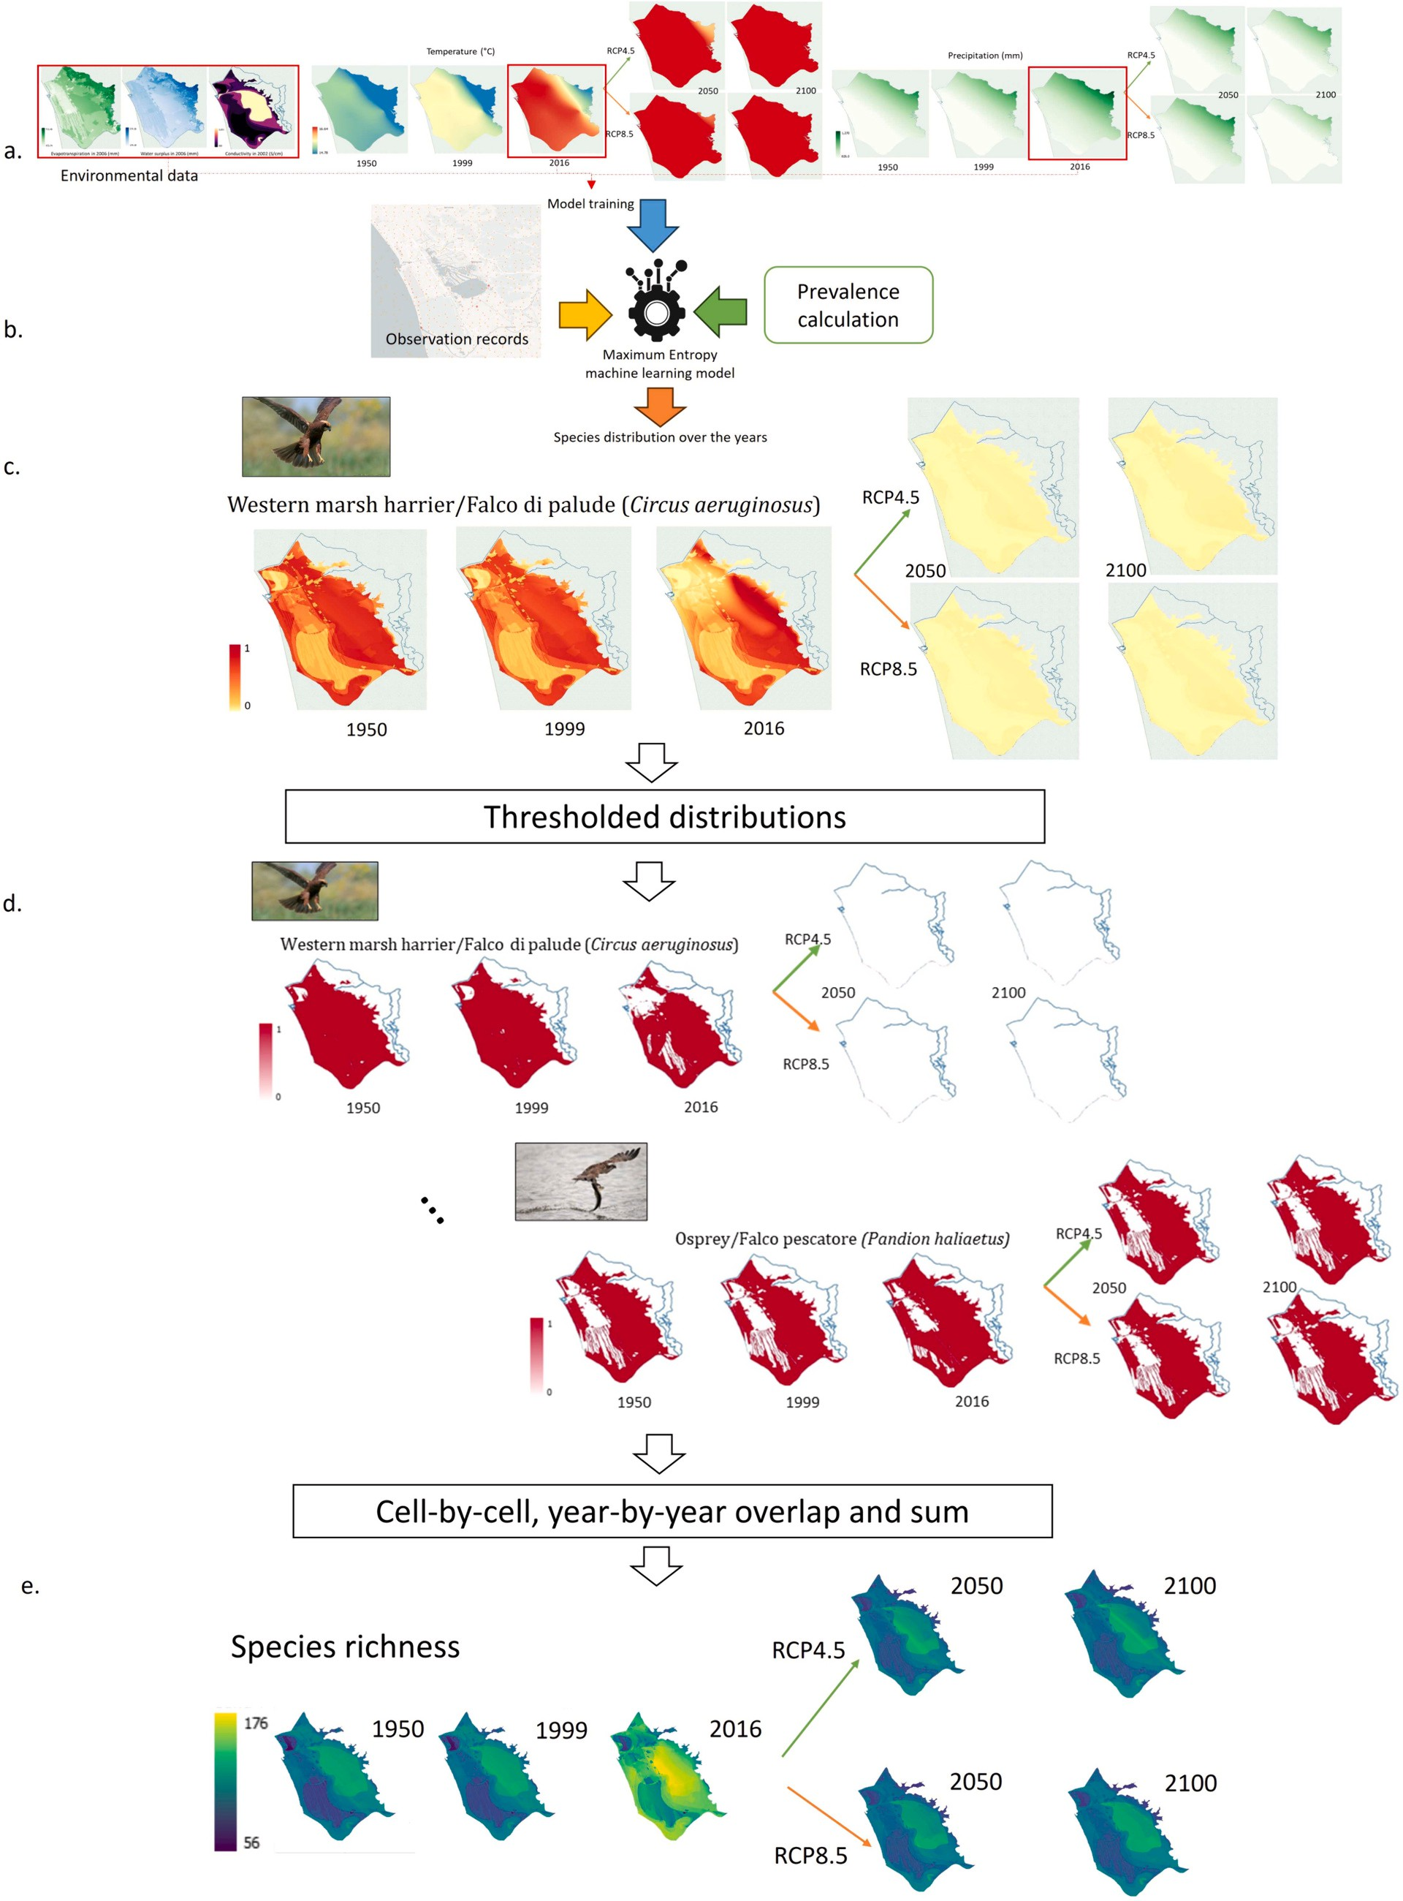

Fig. 3. Overall schema of our modelling approach: Input data from 2016 were used to train MaxEnt-based ecological niche models (a). Each MaxEnt model was fed with species occurrence and prevalence data (b) to produce spatial species distributions over the years for 180 species (c), which were then binarised through thresholding (d). Finally, species richness was obtained through model overlapping and summing (e).

Although an ensemble of models would have been a valid alternative in our scenario (Coro et al., 2018; Coro et al., 2022a; Zhu et al., 2021), we propose combining an X-Means clustering algorithm with a MaxEnt model to form a new Bayesian model. Cluster analysis simulates prior expert knowledge about wetlands before seeing the Massaciuccoli data. It simulates questions like “Is the Eurasian coot easily observable in the Massaciuccoli Lake basin?” posed to an Italian-wetland expert before visiting the basin. This strategy can reduce data overfitting risk: If the species observations in the area were few because of sub-sampling, the model’s likelihood would overfit the data, but the prior probability would increase the overall habitat suitability probability through the Bayes’ rule. For example, even if the Eurasian coot had few observations associated, a high prior would improve the model’s generalisation of the species’ presence in the basin. Using automatically estimated priors was also functional to produce objective prevalence assessments and over-come the frequent criticism that Bayesian models’ results are too influenced by subjective priors based on personal expertise (Elith et al., 2011a; Ward et al., 2009). MaxEnt was a suitable solution to build a Bayesian model that could easily incorporate objective priors. Moreover, since it can work with species-presence data only, it was suitable for our case study which lacked reliable absence (or pseudo-absence) data at the basin scale.
Another source of bias for ENMs originates from the species’ envi-ronmental parameter ranges inferred (Pearson et al., 2006): A model trained on a species’ native habitat at the global scale will extrapolate ranges and relations that might be insufficient for regional-scale ana-lyses, especially for areas not included in the training set (Guinan et al., 2009; Pr´eau et al., 2020). Specifically, learning from large-variance parameters at the global scale can make models unable to appreciate small variations within a limited area, which might even fall outside the learned ranges. Therefore, a consistent approach is to learn from the data at the regional scale directly, while using knowledge from larger scale analyses as prior information (Magliozzi et al., 2019). For this reason, we trained MaxEnt directly at the Massaciuccoli Lake basin scale to extrapolate basin-specific environmental parameter ranges, while simulating larger-scale prior information through prevalence.

  - Species richness estimation

Using the dichotomic threshold, we binarised the ENM spatial pro-jections into spatial distribution maps reporting 1 (suitable locations) or 0 (unsuitable locations) for each species (Fig. 3-d). To this aim, we assigned, to each cell, 1 if the model value was higher than the threshold, and 0 otherwise. We conducted this operation on all our 1260 species spatial distributions to obtain new binary ESRI-GRID raster data. From these, we calculated an overlap index estimating the total, cell-wise species’ habitat suitability, i.e., we cell-wise summed the species’ binary distributions in each year (Fig. 3-e). This index measured the number of different species potentially living in each cell, i.e., the species richness. This is a common approach for measuring species richness that can produce reliable macroscopic information for long time frames, although not considering species’ mutual interactions (Coro et al., 2016a; Pearson, 2007).
The entire modelling process described so far can be summarised as follows:
Algorithm 2. Species richness estimation.

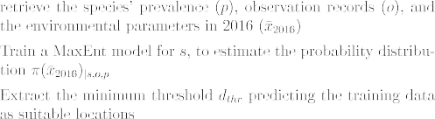
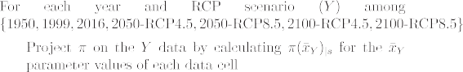
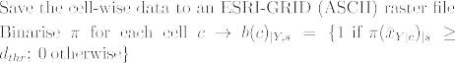

As a result, this algorithm produced one spatial distribution (in the ESRI-GRID format) for each year and species group analysed, reporting the total number of species’ models indicating suitable habitat at a ~ 0.0005◦ (~50 m) spatial resolution.

  - Case study

The Massaciuccoli Lake basin covers a 114 km² area delimited by the Camaiore River to the North, the Oltre Serchio Mountains to the East, the Serchio River to the South, and the Tyrrhenian Sea to the West
(Fig. S1). The lake has a 13 km² area and a depth between 1.0 and 2.5 m, containing about 14 Mm³ of water (Baneschi, 2007; Ciccolini et al., 2013; Rossetto et al., 2010a; Rossetto et al., 2010b). The principal water source depends on the pluvial regime of the eastern mountains and the neighbour soils, extensively used for agriculture. The lake water re-sources are connected with the intensity of human activities around the basin, which include agriculture (counting for 40% of the total activ-ities), farming, cereal and industrial production, horticulture and olive
tree orchards, and train railways (Silvestri et al., 2019). Two water-depuration plants are active in the basin, discharging effluents to the lake.
We applied our species richness estimation algorithm to the 180-spe-cies data in our occurrence record set for the Massaciuccoli Lake basin. The species richness estimation algorithm produced 7 spatial distribu-tions when executed on all species. However, to improve the analysis granularity, we repeated the process for different animal groups in our data, i.e., birds, insects, and other three different groups altogether (reptiles, amphibians, mammals, fishes and crustaceans) hereafter named other species (Section 2.3). These groups are indirectly related to many ecosystem services in the basin, including touristic and economic services (Colombaroli and Tinner, 2013). Therefore, we produced 28 species-richness distributions, i.e., 7 distributions for each species group
(7 × 4 = 28).
As the evaluation strategy, we first analysed the T and P trends across the years to outline the climate change scenarios and patterns from the past to the possible futures. Secondly, we evaluated the expansion/ contraction trends and similarities between pairs of species richness distributions over the years. We conducted these analyses for each of the four species groups identified, to highlight the biodiversity changes that occurred in the basin from 1950 to the near past (2016) and the possible future natural developments without regulations by governmental authorities.
We measured pairwise change and similarities between the distri-

butions. To this aim, we used map-comparison metrics proposed by other studies (Coro et al., 2014; Coro et al., 2016a). In particular, for comparing two data distributions (A and B), we measured (i) the overall trend from A to B (expansion, contraction, or stationarity) and (ii) the per cent growth/decrease of B with respect to A (i.e., considering A as a previous temporal scenario). We used the 25th percentile upper limit of the 2016 data to distinguish between high- and low-value cells (named A_{l}, A_{h}, B_{l}, B_{h}, respectively). We used the 2016 data for this operation to have a uniform reference for all years. After that, we calculated and annotated the cell-wise agreement on high and low values between the two distributions. For example, A_{l}B_{l} indicated agreement by A and B on assigning a low value to the same cell, whereas A_{h}B_{l} indicated disagreement (with A assigning a high value and B a low value to the cell). Indicating cell counting operation as ∣⋅∣, we calculated the following distribution-comparison quantities:
Trend = ( )
|A_{l}B_{h}| — |A_{h}B_{l}|
^{A→B} |A_{l}B_{h}| + |A_{h}B_{l}|
Growth = (|A_{l}B_{h}| — |A_{h}B_{l}|)
A→B |Ah |

In our evaluation, for simplification, we only reported the Trend sign, interpreted as contraction (negative), expansion (positive), or statio-narity (zero).
For the species richness distributions, we added two more metrics that evaluated the overall similarity and agreement between two dis-tributions:
(|A_{l}B_{l}| + |A_{h}B_{h}|)

Results

  - Trend analysis

Trend analysis highlighted that annual T has and would constantly increase over the years (Table 3 and Fig. 2-a). The Trend assessment between consecutive years or scenarios was always of expansion type. Significantly lower temperatures would likely remain in the mountain areas up to 2100. However, high-temperature cells would saturate the basin in 2100 under the RCP4.5 and RCP8.5 scenarios, reaching alti-tudes as high as 300–400 m. The quartile distribution (Fig. S4-a) confirmed the temperature-increase trend (summarised by the median) and the enlargement of higher quartile ranges that would include more and more cells. The Growth table (Table 3) indicated that from 2016 to 2050 the high-temperature extent would likely increase of 28.5% and 33% (in the two RCP scenarios, respectively), and of 33.3% in all 2100 scenarios (up to basin area saturation). The table also revealed that only a few cells in 2050 would not be covered by high temperatures, because Growth in 2100 was minimal. It is worth noting that Growth values were unavailable for 1999 and 1950 because temperatures in those years were always lower than the second quartile of the 2016 temperatures.
The case of Precipitation was different because it did not show a
monotonic trend but rather a curve with a peak in 2016 (Table 3 and Fig. 2-b). Precipitation likely increased from 1950 to 2016 and would decrease in the future, reaching the minimum median value in 2100 under the RCP8.5 scenario (Fig. S4-b). This trend predicts a future of generally higher aridity. In 2050, the median precipitation in the ana-lysed area would increase under the RCP8.5 scenario more than in the

SimilarityA→B =

AgreementA→B =

|A|
SimilarityA→B — Chance Agreement 1 — Chance Agreement
( )
RCP4.5 scenario. The Growth table (Table 3) reflected a general decrease from 2016 to 2050, between —29.2% and — 41.7% (in the two RCP scenarios, respectively), and between —52.8% and — 75.8% from 2016 to 2100.
The combination of the T and P modulations and the ET, WS, and C

AgreementA→B is indeed Cohen’s Kappa (Cohen, 1960), which esti-mates the agreement between the two distributions with respect to a
purely random agreement (chance agreement). To simplify the reading, we only reported Kappa interpretation according to Landis & Koch (Landis and Koch, 1977), i.e., Poor (<0), Slight (0.01–0.20), Fair
(0.21–0.40), Moderate (0.41–0.60), Substantial (0.61–0.80), or Almost
perfect (0.81–1.00).
As an additional test, we verified how much the 2016 and the (extreme) 2100-RCP8.5 scenarios were overall different habitats (being all other differences lower than this), independently of the ENMs. Complete habitat alteration could indeed justify potential species pres-ence change independently of the model estimating them. We measured habitat dissimilarity through the Habitat Representativeness Score (HRS) (MacLeod, 2010). HRS is based on Principal Component Analysis (PCA) (Abdi and Williams, 2010) and measures how much the envi-ronmental data representing two regions are similar across the largest data variance axes (principal components). The algorithm applies PCA to the environmental parameter values of a reference region (A). The environmental parameters thus constitute the original vector space of the PCA projection. After that, the algorithm projects the parameter values of a compared region (B) onto the PCA space calculated on the A vectors. Finally, it calculates the distributions of the A and B values on each principal component separately, over several bins, and then pair-wise subtracts them (with total difference normalised to 1). The HRS is the sum of the total differences calculated on each principal component. It can range from 0 (complete dissimilarity) to the number of principal components (representing perfect, 100% habitat similarity). With respect to other measurements (e.g., MESS maps (Elith et al., 2010)), HRS has the advantage of representing habitat similarity as a percentage (over the maximum value), which allows for quickly interpreting it.
parameters within the MaxEnt models, resulted in complex patterns that could be observed in the species-richness change over the years. The analysis of the all-animals’ group highlighted a high Similarity and Agreement between the 1950 and 1999 species-richness distributions (97.2%) and between the 2050 and 2100 distributions in all RCP sce-narios (90.9–97.5%) (Table 4 and Fig. 4-a). The 2016 scenario presented medium-low Similarity and Agreement with all future scenarios (34.8–41.6%). The Trend assessment from 2016 towards the future scenarios demonstrated a general contraction and substantial decrease
in future species richness (with Growth ranging between —79.1% and —
88.4%). The quartile distribution highlighted an averagely increasing trend of species richness and higher-quartile expansions from 1950 to 2016, followed by a slight species-richness decrease from 2016 to all future scenarios (Fig. S4-c).
Analysing all species as one group hid the reality behind biodiversity changes, because some subgroups indeed showed habitat gain and others habitat loss. In fact, an analysis of the Birds group (Table S1 and Fig. 4-b) highlighted similar or increasingly suitable conditions from 1950 to 1999 and 2016, with a constant expansion Trend. A 1.5% Growth measured between 1950 and 1999, and a 72.1% Growth be-tween 1999 and 2016, enforced this observation. However, all mea-surements between 2016 and the future scenarios indicated potential problems for bird species conservation. Bird species richness was esti-
mated to decrease between —98.3% in 2050 (under RCP4.5) and —
99.9% in 2100 (under RCP8.5) in the study area. The low Similarity and Agreement between the 2016 and the future distributions indicated habitat loss and distribution change. The quartile distribution reflected this scenario and showed a sudden species-richness decrease and quar-tile range reduction after 2016 (Fig. S4-d).
On the contrary, the analysis of the Insects group (Table S2 and Fig. 4-c) highlighted a full Similarity and Agreement between the 1950 and 1999 scenarios but a low Similarity between these past scenarios and the 2016 scenario. This observation seems to disagree with the expansion

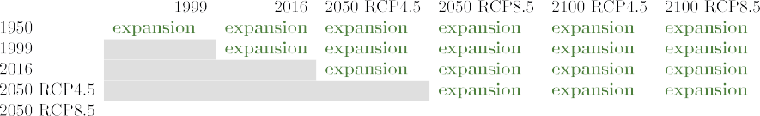
Trend and Growth parameter values for Temperature and Precipitation across the years and RCP scenarios used in our study.

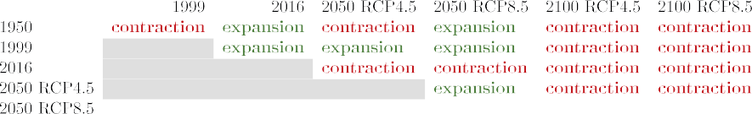
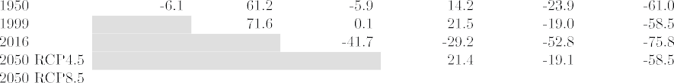

Trend estimated for 2016 with respect to the past. However, this discrepancy was only a consequence of the spatial distribution changes of many species gaining new habitats while losing a few areas. Insect richness in 1950 and 1999 was indeed lower than the 2016 richness’ 25th percentile (Growth was consequently undefined from those years). The 2016 insect richness distribution had a medium-high Similarity (75.8%–77%) with all future distributions, and presented future expansion Trends. The predicted habitat Growth in the future scenarios ranged between 31.6% and 33.2%. The mutual Similarities between the future distributions was also high. Only the 2050-RCP4.5 distribution was slightly less favourable (contraction Trend) than the 2050-RCP8.5 distribution. A minimal, positive Growth was measured between the 2050 and 2100 scenarios. The quartile distribution reflected the signif-icant increase in the insect-group richness from the past to the future (Fig. S4-e).
The Other species group presented different aspects than the previous groups (Table S3 and Fig. 4-d). The 1950 and 1999 environmental conditions were less suitable than the 2016 conditions, especially for terrestrial species. The Trend across the years was generally increasing (expansion), with a slight contraction from the 2050-RCP4.5 to the 2050-RCP8.5 scenario. Growth from 2016 to the future scenarios ranged be-tween 31.5% (2050-RCP8.5) and 34.1% (2100-RCP8.5). However, the 2016 species richness distribution significantly disagreed with the future species richness distributions because of a large shift of suitable area
locations for most species. The inverse of Similarity (1-Similarity) indi-cated an amount of area shift between 23.6% (2050-RCP4.5) and 25.3% (2100-RCP8.5). Major discrepancies were observable in the significant habitat gain for most species from 1950 to 2016 (especially for terres-trial species such as wild boards and deers), followed by an overall bulk movement towards lower temperature areas with more water available, e.g., the mountains. The quartile distribution reflected the general habitat increase over the past years, and reported stationary future ranges corresponding to habitat shift rather than increase (Fig. S4-f).

  - Sensitivity analysis

We simulated future and past variations of ET, WS, and C to evaluate our assumption that the potential variations of these parameters in the analysed time frame did not influence the extracted species-richness trends. Before the simulation, we verified that these parameters were important for our ENMs by analysing their percentage contributions to the MaxEnt models. The number of species for which at least one of these parameters overcame a significant percentage contribution (5%) was 90.2%. The species percentage was 81.1% for a 20% minimum contri-bution, and 51% for a 50% minimum contribution. Therefore, the pa-rameters were important for our models. Moreover, we observed that they could substitute parameters such as bathymetry and water presence in producing consistent results, e.g., predicting fish presence in water

Table 4
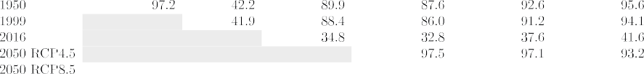
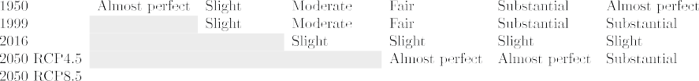
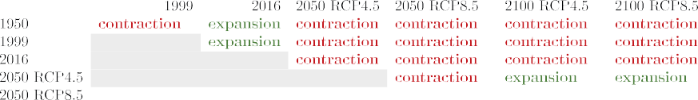
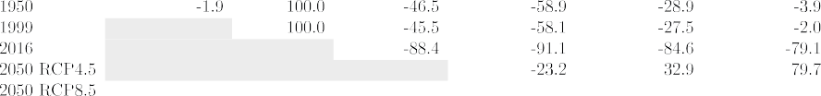
Similarity assessment, Agreement (interpreted according to Landis and Koch, (1977)), Trend and Growth estimates for the species-richness distributions over the years and RCP scenarios produced for the present study. The table refers to the analysis of all animal-species involved in our study.

areas only. We also verified that bathymetry (from GEBCO) had very low contribution when ET, WS, and C were used.
Between the extreme and different 1950 and 2100-RCP8.5 scenarios, the maximum per-cell T and P variations were 12.6% and 11.7%, respectively. Based on the Thornthwaite formula (Thornthwaite, 1948) and reusing the results of other sea-close-wetland analyses (Aras and Celik, 2019), the maximum ET variation per cell resulted approximately 3% around the ET values in 2006. This percentage was the entity of the approximation for considering ET constant over the years (relative error). Similarly, fixing WS to the 2006 values coarsely corresponded to a ~ 5% relative error (Aras and Celik, 2019; Guo et al., 2021). We also assumed an (overestimated) ~ 5% relative error for C because it directly depends on WS.
We tested the sensitivity of our results to these errors by simulating a new 1950 scenario with ET values reduced by 3% of the 2006 values, and a 2100-RCP8.5 scenario with values increased by 3%. We also simulated the intermediate 1999 and 2050-RCP8.5 scenarios using lin-early decreased and increased percentages, respectively, from the mid-
dle of the variation range (±1.5%). We repeated the same simulation for
the WS and C data using a 5% maximum relative variation. After that, we spatially projected our ENMs on the simulated data and aggregated the distributions to produce new species richness distributions over the years. Finally, we evaluated if the trends still corresponded to the ones reported in Section 3.1.
Fig. 5 shows the average species richness, per species group, for the simulated data compared to the one from our previous results using fixed values (original). The simulated trends were the same as the
original trends for all groups. Year-wise discrepancy ranged between (i) 1.9% and 10.2% for all animal species analysed, (ii) 0.4% and 1.9% for birds, (iii) -7.0% and 23.8% for insects, and (iv) -10% and 0% for other species. Growth estimates indicated very similar temporal variations between the original and simulated scenarios. For example, the overall decrease in the all-species richness from 2016 to 2100-RCP8.5 was
—79.1% (original) vs —82.07% (simulated). The average decrease for birds was —99.9% (original) vs —93.4% (simulated). Conversely, the
average increase for insects was 33.2% (original) vs 39.1% (simulated), and 34.1% (original) vs 36.3% (simulated) for the other species. Increasing species richness from the past to 2016 was also visible in the simulated data. In particular, bird species richness increased by 48.8% from 1950 to 2016 and by 48% from 1999, in compliance with the original results.
These results imply that ET, WS, and C could reasonably be fixed to the original Authority-data values. Their variations were mostly included in the larger T and P variations, which reduced the influence of the other (smaller and correlated) variations. For completeness sake, we specify that fixing these parameters also implied to assume constant land cover and geomorphological parameters over the years.
As an additional check, we verified that the species-richness changes were possibly not an artefact of the MaxEnt model extensions but could be due to significantly different overall habitat conditions. To this aim, we tested, through HRS, how much the future conditions in 2100-RCP8.5 differed from the 2016 conditions independently of the ENMs. The HRS between the 2100-RCP8.5 and the 2016 scenarios was ~20% (17%, using simulated parameter variations). Therefore, the habitats

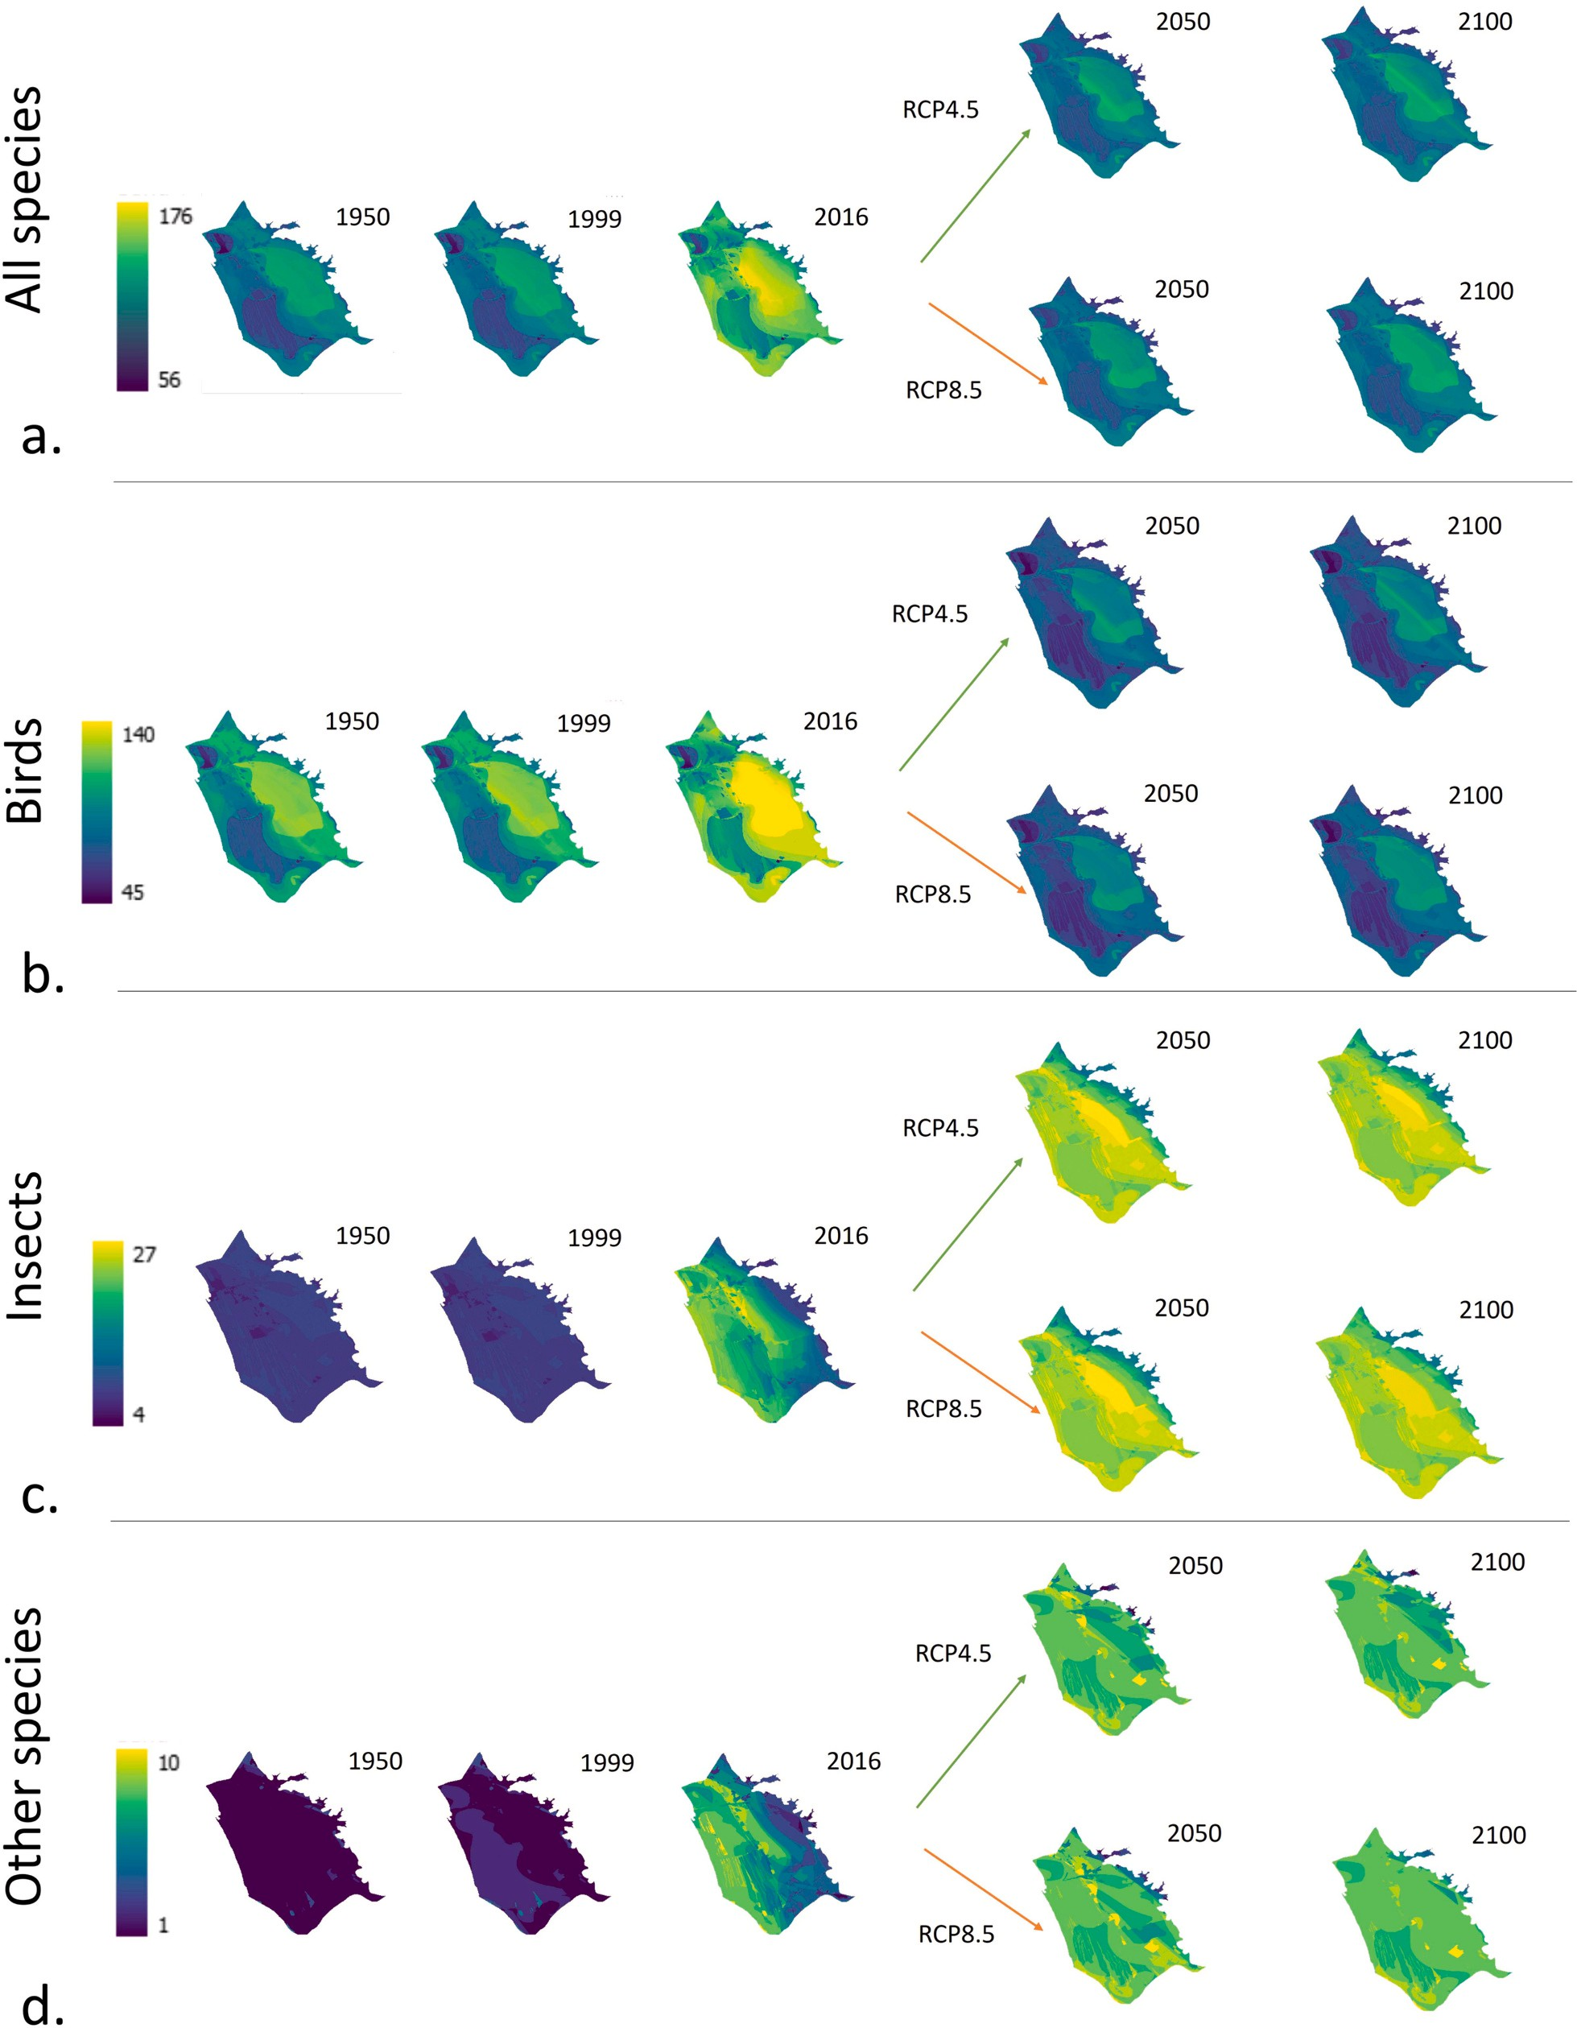

Fig. 4. Species richness distributions over the years and the RCP4.5 and RCP8.5 scenarios for 4 different animal groups living in the Massaciuccoli Lake basin: All selected animal species (a), birds (b), insects (c), and other species (reptiles, amphibians, mammals, fishes and crustaceans) (d).

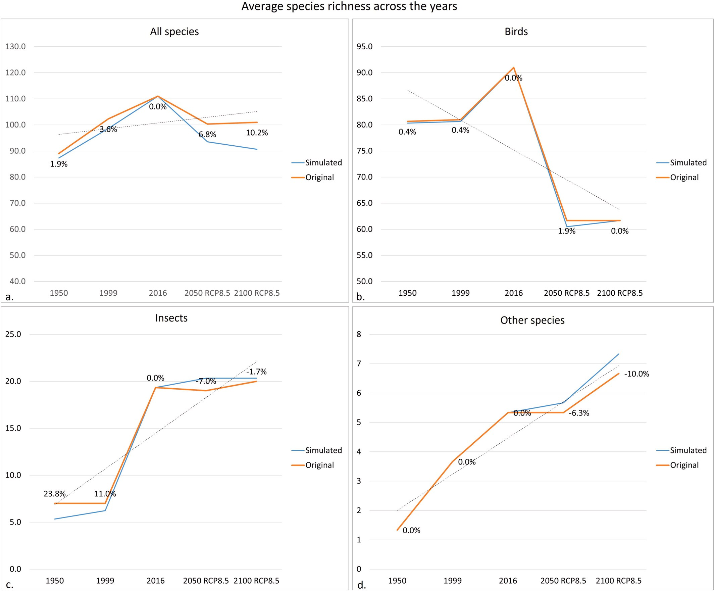

Fig. 5. Comparison of average species-richness variation from past to future years (under the RCP8.5 scenario). The charts compare the results obtained by fixing Evapotranspiration, Water surplus, and Conductivity data to the Authority data values in the 2000s (original) with simulated variations of these parameters over the years (simulated). The charts are reported for 4 different animal groups living in the Massaciuccoli Lake basin: All selected animal species (a), birds (b), insects (c), and other species (reptiles, amphibians, mammals, fishes and crustaceans) (d). The dotted lines indicate the overall variational trends. The percentages indicate the point-wise per cent variation from the original species-richness average to the simulated one.

were very dissimilar independently of the ENMs, i.e., the overall envi-ronmental parameters’ distributions and their mutual variations would sensibly change in the future. Consequently, the species-richness change highlighted by our results was consistent with this dissimilarity.

Discussion and conclusions

  - Result summary

Our trend analysis estimated a constant increase of temperature from the past to the future, in compliance with the vast majority of climate change studies (Alexeeff et al., 2018; Coro et al., 2020; Coro et al., 2023; Dai, 2013; Dosio, 2016; Karl et al., 2015; Lewandowsky et al., 2015). Precipitation showed a peak in 2016 and then a concentration in the mountain areas, in compliance with other studies (Coro et al., 2020; Coro et al., 2023). The overall species richness would strongly change in the shorter-term (2050) and longer-term (2100) future in both the me-dium (RCP4.5) and high (RCP8.5) greenhouse gas emission scenarios.
The temperature and precipitation change over the last 70 years might have benefited animal biodiversity. Therefore, the lower number of species - especially birds - reported in GBIF for the past might also relate to previous species absence, in agreement with local-experts’ consider-ations (Section 2.3). However, the expected drying of most of the basin, with heavy precipitation confined more and more to the mountain areas, would negatively affect species composition in the future. It is worrying that even the reduced emissions of the RCP4.5 scenario would be insufficient to stop this change. Birds will likely be the most impacted group, with an extensive species-richness loss in 2100. Intense changes would also occur in 2050 in both the RCP scenarios. On the contrary, the selected insect-group’s habitat suitability has increased and will likely increase in the short- and long-term future. This trend might not be generalisable to all insects living in the basin, since the group accounts for only 22% of the total insect species reported in GBIF. Moreover, a general increasing trend for a species group does not exclude that some species (including endemic or endangered) representing a minor but very important percentage might go extinct because of future habitat

unsuitability (Marta et al., 2021). Finally, terrestrial and water species will likely move towards water-richer and cooler areas, radically changing their presence in the basin.
All involved environmental parameters had a high influence on most species’ distributions. However, it is impossible to identify one primary driver of the detected species-richness change. A complex combination of parameters within the MaxEnt models produced the presented results. The Habitat Representativeness Score indicated that significant differ-ences existed between the overall climatic conditions of 2016 and 2100-RCP8.5, with lower but still significant differences between 2016 and the other years. These differences indicate that species-richness changes should be expected independently of the species-richness modelling approach used.

  - Indications for policy-making authorities

Our results indicate that climate change poses severe risks to the vulnerability of the species living in the Massaciuccoli basin, and consequently to the ecosystem services relying upon them. A significant species-composition change already in 2050 would negatively impact the entire ecosystem, with ecological and economic consequences (Colombaroli and Tinner, 2013; Pignalosa et al., 2022b). These findings call for policy-making authorities to take actions as soon as possible to mitigate the risks. The same conclusions about future biodiversity asset and ecosystem service degradation were drawn by other studies focus-sing on eutrophication and drought monitoring, which have proposed water drainage and refuelling mitigation strategies (Bertacchi et al., 2015; Pignalosa et al., 2022c; Rossetto et al., 2010b). These consider-ations enforce our result reliability further. A few safeguard initiatives are indeed undergoing (Regione Toscana, 2018), which mostly plan to guarantee water presence in the lake. However, they are acting too slowly to meet the change already occurring in the basin. Our results constitute the first numeric assessment of the timing and intensity of the change, which can be used as a reference for management planning.

  - Advantages and drawbacks

    - Model prediction beyond the training ranges
We trained the MaxEnt ENMs directly on the Massaciuccoli Lake basin environmental data instead of using global-scale ranges. This choice brought drawbacks and advantages. Global-scale parameters would have allowed the model to better appreciate each species’ toler-ance to the parameters, e.g., the thermal tolerance by studying the species’ presence in an extensive range of temperatures. Therefore, the MaxEnt model would have produced parameter-specific distributions covering large parameter ranges. However, large-variance parameters (such as global-scale parameters) decrease the resolution of parameter variations and hide small modulations that are crucial when studying habitat suitability in a limited area (Mushtaq et al., 2021; Wan et al., 2019). The MaxEnt parameter-specific probabilities would be coarser than those based on regional-scale parameters. Therefore, in line with other approaches (Holt et al., 2018; Kumar et al., 2014; Owens et al., 2013; Piekielek et al., 2015; Stohlgren et al., 2011), we used regional-scale parameters to extract species-environment relationships at a higher resolution. This choice allowed our ENMs to better model the non-linear relations between the species and the selected environmental parameters. The drawback was that the models needed to automatically infer how to deal with broader temperature and precipitation ranges.
To manage this issue, we followed the practice advised by other studies (Coro et al., 2022c; Elith et al., 2011a) to disable clamping in MaxEnt. This option allows the model to extend the estimated proba-bility distribution beyond the parameter ranges observed on the training set. Since MaxEnt learns a complex, multidimensional function between the observations and the environmental parameters, it is hard to eval-uate the overall goodness of its extension precisely. However, the single-parameter response curves (i.e., the marginal distributions) can be used
as indicators. In particular, we verified that the single-parameter curves consistently continued the trends at the range limits. In our case, the models had to reach T and P values ~16% outside the training bound-aries to cover the 1950 and 2100-RCP8.5 scenarios. We sample-checked, across the species, that the extensions continued with monotonic increasing or decreasing trends outside the range ends, always indi-cating a suitability/unsuitability value similar to those at the range ends. In summary, the single-parameter curves reasonably covered the slight range extension. It is worth noting that this extension was helped by larger-scale prior information provided by prevalence estimation. This scenario’s reliability is also supported by the consideration that the projection insists on the same region as the training data (Owens et al.,
2013; Stohlgren et al., 2011).

    - Data limitations
Using only public FAIR data to build our models guaranteed the reproducibility and repeatability of the results. Other studies have demonstrated that the parameters we used for the present study can be sufficient for species-richness modelling in other areas (Coro et al., 2016a; Midgley et al., 2002). We also demonstrated the high contribu-tion of the parameters to our models. Moreover, the approximate as-sumptions of averagely constant values across the years we made for ET, WS, and C were tolerable because the inferred species-richness trends were robust to significant variations of these parameters. However, the selected parameters might be incomplete for modelling other change factors for the Massaciuccoli basin biodiversity. For example, we did not include land use and land cover changes, water and ecosystem man-agement, pollution, and other direct human impact that could further alter the depicted scenarios. To cover these aspects, we are planning a new data census and collection campaign based on other public FAIR data repositories (e.g., from the Tuscany Region administration to Copernicus (Bertacchi, 2017; Bhardwaj and Khaiter, 2023; Th´epaut et al., 2018; Trevisani, 2014)). These data will likely have a coarser spatial resolution than the data we used and will require sophisticated data-harmonisation strategies to allow us to build regional-scale models.

    - Limitations and extensions
It is essential to highlight that, in the spirit of big-data analyses, our results should be considered as macroscopic indications of overall species-richness trends (per group) rather than as cell- and species-wise detailed answers (Coro et al., 2022a; Queiroz et al., 2021). An erroneous or missing indication of one species’ presence (or species richness) in a cell is not important if most of the cells were correctly predicted and a sufficient number of species was used (we used ~50% of all GBIF-reported animals in the basin). The biases blur when several models are aggregated and can fade away when overall trends are the target of the study (Coro et al., 2024; Hannemann et al., 2016; Iannella et al., 2018). The highlighted general patterns and temporal trends should be considered the principal targets and results of the present paper. We also demonstrated their low sensitivity to ET, WS, and C variations.
Although our results are based on approximations, they are valuable
for several additional analyses to understand future biodiversity change directions and implications on ecosystem status and extract environ-mental trends and food web in the basin (Jarnevich et al., 2015; Melo-Merino et al., 2020; Nieto-Lugilde et al., 2018; Sinclair et al., 2010). Generally, multi-species ecological niche models (MSENMs) like ours are quick methods to generate an overview of species richness and es-timate complex correlative relationships between overall species pres-ence and environmental parameters (Barbet-Massin and Jetz, 2014; Boyd and Foody, 2011; Sidumo et al., 2022). One drawback is that they do not explicitly incorporate mutual species interactions, such as competition, predation, or mutualism (Austin, 2007; Kissling et al., 2012). Nevertheless, this approximation may still be valid in specific contexts, especially when using yearly-aggregated environmental pa-rameters. First, mutual species interactions can operate on various temporal scales, from short-term interactions (e.g., seasonal competition

for resources) to long-term dynamics (e.g., co-evolutionary relation-ships). The omission of mutual interactions can be less problematic for short-term dynamics when using annual environmental variables and reduces model overfitting risks (Araújo and Guisan, 2006; Norberg et al., 2019; Pearson and Dawson, 2003; Urban et al., 2016; Wisz et al., 2013). Second, mutual species interactions often occur at localised spatial scales. In contrast, MSENMs typically operate at broader spatial extents, where individual species interactions at an annual scale may be diluted across the area, and the approximation might be more acceptable.
Our primary goal was indeed to understand broad-scale patterns of species richness and habitat suitability rather than investigating fine-scale ecological processes or predicting community dynamics. MSENMs do not aim to capture the complexity of the entire ecological system; instead, they address the complexity of the species-environment relationship. Adding mutual species interaction would have introduced additional complexity and uncertainty to our models, which was not justified given our goal. MSENMs commonly delegate aspects such as population dynamics and food web modelling to ecosystem models (EMs). EMs can use the output of MSENMs to simulate and understand food web and ecosystem dynamics (Guisan and Thuiller, 2005; Robinson et al., 2017; Wang, 2019). For example, EMs based on Bayesian Net-works (BNs) can incorporate MSENM output as prior information in their nodes (Ha¨ussler et al., 2020; Lyu et al., 2022; Lyu et al., 2024; Wang et al., 2024). Species presence, general habitat suitability (e.g., from MSENMs), and environmental parameters are often modelled in BNs as prior probability nodes. A BN usually incorporates information on species interactions as additional nodes and connections, and models their effects on prior species distributions and ecosystem dynamics. Bayesian inference updates all nodes’ probabilities based on additional evidence and observations (e.g., remote sensing and ecological moni-toring campaigns). The BN eventually quantifies uncertainty in the ecosystem predictions and the MSENMs retrospectively. Therefore, EMs can build upon MSENMs to (i) improve species composition and spatial pattern knowledge (Bulmer et al., 2022), (ii) infer population dynamics and community structure (Spiers et al., 2016; Trifonova et al., 2021),
(iii) detect broad patterns of species richness and ecological commu-nities across environmental gradients (Hui et al., 2022), and (v) simulate the relations between species composition/distribution and ecosystem services (Bourhis et al., 2023; Felipe-Lucia et al., 2022; Kang et al., 2024; Kissling et al., 2012). MSENMs can also provide input to spatial planning models for biodiversity and ecosystem service conservation. These models can combine the MSENM output with climate projections and land-use scenarios to identify potential future trajectories of ecosystem change and evaluate the effectiveness of different conservation and management interventions (Beger et al., 2022; Devarajan et al., 2020; Franklin et al., 2011).
In summary, our results have a moderately limited ecological point, and should be considered as a general approach that can support pre-liminary management measures and awareness campaigns (Hilbert, 2016; Queiroz et al., 2021; Sun and Scanlon, 2019; Valerio et al., 2024). Their value would increase when used in ecosystem and spatial planning models and generally when combined with other ecological data and models. Additionally, they would pave the way to developing a digital twin of the study area (Campana et al., 2021).

    - Modelling approach suitability and reliability
We used a modelling approach suited for the problem and data at hand. Moreover, we relied on citizen science to collect updated, accurate species observations on the field and consequently support the model’s sensitivity to data quality. Our study also injected prevalence into the models as a larger-scale knowledge about wetlands to reduce overfitting risks and further enhance model reliability. Some extracted trends (e.g., for birds) also agree with local experts’ knowledge. Compared to other biodiversity studies conducted on the Massaciuccoli Lake basin that highlighted similar environmental-parameter and species-richness trends (Bertacchi et al., 2015; Colombaroli et al., 2007; Colombaroli
and Tinner, 2013; Colombini et al., 2013; Giugliano et al., 2011; Las-trucci et al., 2017), we have produced the first spatially-explicit assessment of animal species-richness trends while estimating the timing of the changes. Differently from other Bayesian approaches (Jarnevich et al., 2015; Joshi and Miller, 2021; Lee et al., 2023), we produced Bayesian models where prior probabilities were estimated by another model that simulated expert knowledge and reduced data overfitting risks.
To be compliant with modern Open Science requirements of repro-ducibility, repeatability, and reusability (Feng et al., 2019), our study was entirely conducted through open-source software and FAIR envi-ronmental and species-observation data. Our code and data are also entirely open source (Section Software and data availability).
Our modelling approach would be valid for analysing other basins with minimal regional-scale environmental data available and studying their species-richness development over time. Our future work will include applications of our approach to other wetland basins monitored by the ITINERIS Italian Ministry-funded project, which develops cross-disciplinary research in environmental sciences and ecology through open data and service reuse (Italian Ministry of University and Research, 2023).

CRediT authorship contribution statement

Gianpaolo Coro: Writing – review & editing, Writing – original draft, Validation, Software, Methodology, Conceptualization. Pasquale Bove: Writing – original draft, Validation, Software, Methodology. Ilaria Baneschi: Writing – original draft, Validation, Methodology. Andrea Bertini: Data curation. Lorenzo Calvisi: Data curation. Anto-nello Provenzale: Writing – original draft, Validation, Methodology, Funding acquisition.

Declaration of competing interest

The authors declare the following financial interests/personal re-lationships which may be considered as potential competing interests:
Gianpaolo Coro reports financial support was provided by ITINERIS PNRR Italian project. Pasquale Bove reports financial support was pro-vided by ITINERIS PNRR Italian project. Antonello Provenzale reports financial support was provided by ITINERIS PNRR Italian project. Ilaria Baneschi reports financial support was provided by ITINERIS PNRR Italian project. If there are other authors, they declare that they have no known competing financial interests or personal relationships that could have appeared to influence the work reported in this paper.

Data availability

The source code and all input and output data are available on the Zenodo repository at https://zenodo.org/record/8380273
The repository contains all data (including ESRI-GRID raster files),
tables, images, animations, and data-manipulation scripts. It is organ-ised as a step-by-step process in subsequent folders. It also includes the list of species used to estimate species richness (https://zenodo. org/record/8380273/files/All_species_modelled.txt) and the complete set of observation records.
All data and scripts are continuously updated on the ITINERIS Crit-ical Zone Virtual Research Environment available on the D4Science e-Infrastructure (Assante et al., 2019; Assante et al., 2022; Coro et al., 2015c; Coro et al., 2017) (https://services.d4science.org/). Free registration to the platform and the Virtual Research Environment are required.

Acknowledgments

This work has been conducted in the context of and funded by the ITINERIS PNRR Italian project (project code No. IR0000032 - ESFRI

Environment). The authors wish to thank Silvio Marta for his precious review and input to improve the study consistency.

Appendix A. Supplementary data

Supplementary data to this article can be found online at https://doi. org/10.1016/j.ecoinf.2024.102644.

References

Abdi, H., Williams, L.J., 2010. Principal component analysis. Wiley Interdiscip. Rev.
Comp. Stat. 2 (4), 433–459.
Alexeeff, S.E., Nychka, D., Sain, S.R., Tebaldi, C., 2018. Emulating mean patterns and variability of temperature across and within scenarios in anthropogenic climate change experiments. Clim. Chang. 146, 319–333.
Alvera-Azc´arate, A., Barth, A., Rixen, M., Beckers, J.-M., 2005. Reconstruction of
incomplete oceanographic data sets using empirical orthogonal functions: application to the adriatic sea surface temperature. Ocean Model 9 (4), 325–346.
Anderson, R.P., Martínez-Meyer, E., Nakamura, M., Araújo, M.B., Peterson, A.T., Sobero´n, J., Pearson, R.G., 2011. Ecological Niches and Geographic Distributions (MPB-49). Princeton University Press, Princeton, U.S.
Angeletti, L., Prampolini, M., Foglini, F., Grande, V., Taviani, M., 2020. Cold-water coral habitat in the bari canyon system, southern adriatic sea (mediterranean sea). In: Seafloor Geomorphology as Benthic Habitat. Elsevier, pp. 811–824.
Aras, E., Celik, E.O., 2019. Investigation of climate type of kizilirmak delta. In: International Civil Engineering And Architecture Conference - IEARC, pp. 782–787.
Araújo, M.B., Guisan, A., 2006. Five (or so) challenges for species distribution modelling.
J. Biogeogr. 33 (10), 1677–1688.
Ashraf, U., Peterson, A.T., Chaudhry, M.N., Ashraf, I., Saqib, Z., Rashid Ahmad, S.,
Ali, H., 2017. Ecological niche model comparison under different climate scenarios: a case study of olea spp. in Asia. Ecosphere 8 (5), e01825.
Assante, M., Candela, L., Castelli, D., Cirillo, R., Coro, G., Frosini, L., Lelii, L., Mangiacrapa, F., Pagano, P., Panichi, G., et al., 2019. Enacting open science by d4science. Futur. Gener. Comput. Syst. 101, 555–563.
Assante, M., Candela, L., Castelli, D., Cirillo, R., Coro, G., Dell’Amico, A., Frosini, L., Lelii, L., Lettere, M., Mangiacrapa, F., et al., 2022. Virtual research environments co-creation: the d4science experience. In: Concurrency and Computation: Practice and Experience, p. e6925.
Austin, M., 2007. Species distribution models and ecological theory: a critical assessment and some possible new approaches. Ecol. Model. 200 (1–2), 1–19.
Austin, P.C., Harrell Jr., F.E., Lee, D.S., Steyerberg, E.W., 2022. Empirical analyses and simulations showed that different machine and statistical learning methods had differing performance for predicting blood pressure. Sci. Rep. 12 (1), 9312.
Baldwin, R.A., 2009. Use of maximum entropy modeling in wildlife research. Entropy 11 (4), 854–866.
Baneschi, I., 2007. Geochemical and Environmental Study of a Coastal Ecosystem: Massaciuccoli Lake (Northern Tuscany, Italy). Ph.D. thesis,. UNIVERSITA` CA’FOSCARI VENEZIA; Universit`a degli studi Ca’Foscari di Venezia.
Barbet-Massin, M., Jetz, W., 2014. A 40-year, continent-wide, multispecies assessment of relevant climate predictors for species distribution modelling. Divers. Distrib. 20 (11), 1285–1295.
Bargain, A., Marchese, F., Savini, A., Taviani, M., Fabri, M.-C., 2017. Santa maria di leuca province (mediterranean sea): identification of suitable mounds for cold-water coral settlement using geomorphometric proxies and maxent methods. Front. Mar. Sci. 4, 338.
Barik, S., Saha, G.K., Mazumdar, S., 2022. Conservation prioritization through combined approach of umbrella species selection, occupancy estimation, habitat suitability and connectivity analysis of kingfisher: a study from an internationally important wetland complex (Ramsar site) in India. Eco. Inform. 72, 101833 https://doi.org/ 10.1016/j.ecoinf.2022.101833. URL https://www.sciencedirect.com/science/ article/pii/S1574954122002837.
Batt, R.D., Morley, J.W., Selden, R.L., Tingley, M.W., Pinsky, M.L., 2017. Gradual changes in range size accompany long-term trends in species richness. Ecol. Lett. 20 (9), 1148–1157.
Beger, M., Metaxas, A., Balbar, A.C., McGowan, J.A., Daigle, R., Kuempel, C.D., Treml, E. A., Possingham, H.P., 2022. Demystifying ecological connectivity for actionable spatial conservation planning. Trends Ecol. Evol. 37 (12), 1079–1091.
Bertacchi, A., 2017. Dune habitats of the migliarino–san rossore–massaciuccoli regional park (tuscany–Italy). J. Maps 13 (2), 322–331.
Bertacchi, A., Lombardi, T., Giannini, V., Silvestri, N., Bonari, E., et al., 2015. A case of ecological renaturation in a drained mediterranean peatland: the case study of the massaciuccoli lake basin (tuscany, it). In: 110◦ Congresso della Societ`a Botanica
Italiana onlus Pavia, 14-17 September 2015: ABSTRACTS KEYNOTE LECTURES,
COMMUNICATIONS, POSTERS, Societa` Botanica Italiana, p. 16.
Bertacchi, A., et al., 2019. Coastal degradation and dune habitats in tuscany coasts (italy): the study case of the regional park of migliarino san rossore massaciuccoli. In: Best Practices in Evaluation and Restoration of Degraded Mediterranean Environments-Monografías do Ibader-Serie Territorio., IBADER. Instituto de de Biodiversidade Agraria e Desenvolvemento Rural …, pp. 162–167.
Bhardwaj, E., Khaiter, P.A., 2023. What data analytics can or cannot do for climate change studies: an inventory of interactive visual tools. Eco. Inform. 73, 101918.
Bourhis, Y., Bell, J.R., Shortall, C.R., Kunin, W.E., Milne, A.E., 2023. Explainable neural networks for trait-based multispecies distribution modelling—a case study with butterflies and moths. Methods Ecol. Evol. 14 (6), 1531–1542.
Boyd, D.S., Foody, G.M., 2011. An overview of recent remote sensing and gis based research in ecological informatics. Eco. Inform. 6 (1), 25–36.
Brink, P.T., Russi, D., Farmer, A., Badura, T., Coates, D., Fo¨rster, J., Kumar, R., Davidson, N., 2013. The economics of ecosystems and biodiversity for water and wetlands: executive summary. Ramsar.org.
Bulmer, R., Stephenson, F., Lohrer, A., Lundquist, C., Madarasz-Smith, A., Pilditch, C., Thrush, S., Hewitt, J., 2022. Informing the management of multiple stressors on estuarine ecosystems using an expert-based bayesian network model. J. Environ. Manag. 301, 113576.
Campana, E.F., Ciappi, E., Coro, G., 2021. The role of technology and digital innovation in sustainability and decarbonization of the blue economy. Bull. Geophys. Oceanogr. 123.
Campos, J.C., Garcia, N., Alírio, J., Arenas-Castro, S., Teodoro, A.C., Sillero, N., 2023. Ecological niche models using maxent in google earth engine: evaluation, guidelines and recommendations. Eco. Inform. 76, 102147 https://doi.org/10.1016/j. ecoinf.2023.102147. URL https://www.sciencedirect.com/science/article/pii/ S1574954123001760.
Candela, L., Castelli, D., Coro, G., Lelii, L., Mangiacrapa, F., Marioli, V., Pagano, P., 2015.
An infrastructure-oriented approach for supporting biodiversity research. Eco. Inform. 26, 162–172.
Capezzuto, F., Sion, L., Ancona, F., Carlucci, R., Carluccio, A., Cornacchia, L., Maiorano, P., Ricci, P., Tursi, A., D’Onghia, G., 2018. Cold-water coral habitats and canyons as essential fish habitats in the southern adriatic and northern ionian sea (central mediterranean). Ecol. Quest. 29 (3), 9–23.
Card, D., Zhang, M., Smith, N.A., 2019. Deep weighted averaging classifiers. In: Proceedings of the Conference on Fairness, Accountability, and Transparency,
pp. 369–378.
Chala, D., Roos, C., Svenning, J.-C., Zinner, D., 2019. Species-specific effects of climate change on the distribution of suitable baboon habitats–ecological niche modeling of current and last glacial maximum conditions. J. Hum. Evol. 132, 215–226.
Chao, A., Chiu, C.-H., 2016. Species richness: estimation and comparison. Wiley StatsRef: Stat. Ref. Online 1, 26.
Ciccolini, V., Giannini, V., Bosco, S., Pellegrino, E., Pistocchi, C., Sabbatini, T., Rossetto, R., Silvestri, N., Bonari, E., 2013. Restoration of a mediterranean drained peatland: the case study of the massaciuccoli lake basin (tuscany, it). In: Extended abstract in International Workshop AWARE Approaches in Wetland Restoration,
pp. 21–23.
Cohen, J., 1960. A coefficient of agreement for nominal scales. Educ. Psychol. Meas. 20 (1), 37–46.
Colombaroli, D., Tinner, W., 2013. Determining the long-term changes in biodiversity and provisioning services along a transect from central europe to the mediterranean. The Holocene 23 (11), 1625–1634.
Colombaroli, D., Marchetto, A., Tinner, W., 2007. Long-term interactions between mediterranean climate, vegetation and fire regime at lago di massaciuccoli (tuscany, Italy). J. Ecol. 95 (4), 755–770.
Colombini, I., Cimo`, F., Chelazzi, L., 2013. Assessment of local biodiversity
Macroinvertebrate diversity, Demetra, Florence, Italy, pp. 59–78. Ch. 3.
Coro, G., 2020. A global-scale ecological niche model to predict sars-cov-2 coronavirus infection rate. Ecol. Model. 431, 109187.
Coro, G., 2024. An open science oriented bayesian interpolation model for marine parameter observations. Environ. Model Softw. 172, 105901.
Coro, G., Bove, P., 2022. A high-resolution global-scale model for covid-19 infection rate.
ACM Trans. Spatial Algorithms Syst. (TSAS) 8 (3), 1–24.
Coro, G., Trumpy, E., 2020. Predicting geographical suitability of geothermal power plants. J. Clean. Prod. 267, 121874.
Coro, G., Pagano, P., Ellenbroek, A., 2013a. Automatic procedures to assist in manual review of marine species distribution maps. In: International Conference on Adaptive and Natural Computing Algorithms. Springer, pp. 346–355.
Coro, G., Pagano, P., Ellenbroek, A., 2013b. Combining simulated expert knowledge with neural networks to produce ecological niche models for latimeria chalumnae. Ecol. Model. 268, 55–63.
Coro, G., Pagano, P., Ellenbroek, A., 2014. Comparing heterogeneous distribution maps for marine species. GISci. Remote Sens. 51 (5), 593–611.
Coro, G., Webb, T.J., Appeltans, W., Bailly, N., Cattrijsse, A., Pagano, P., 2015a.
Classifying degrees of species commonness: North Sea fish as a case study. Ecol. Model. 312, 272–280.
Coro, G., Magliozzi, C., Ellenbroek, A., Pagano, P., 2015b. Improving data quality to build a robust distribution model for architeuthis dux. Ecol. Model. 305, 29–39.
Coro, G., Candela, L., Pagano, P., Italiano, A., Liccardo, L., 2015c. Parallelizing the execution of native data mining algorithms for computational biology. Concurrency Comput. Pract. Exp. 27 (17), 4630–4644.
Coro, G., Magliozzi, C., Ellenbroek, A., Kaschner, K., Pagano, P., 2016a. Automatic classification of climate change effects on marine species distributions in 2050 using the aquamaps model. Environ. Ecol. Stat. 23, 155–180.
Coro, G., Magliozzi, C., Berghe, E.V., Bailly, N., Ellenbroek, A., Pagano, P., 2016b.
Estimating absence locations of marine species from data of scientific surveys in obis. Ecol. Model. 323, 61–76.
Coro, G., Panichi, G., Scarponi, P., Pagano, P., 2017. Cloud computing in a distributed e-infrastructure using the web processing service standard. Concurrency Comput.
Pract. Exp. 29 (18), e4219.
Coro, G., Vilas, L.G., Magliozzi, C., Ellenbroek, A., Scarponi, P., Pagano, P., 2018.
Forecasting the ongoing invasion of lagocephalus sceleratus in the mediterranean sea. Ecol. Model. 371, 37–49.

Coro, G., Pagano, P., Ellenbroek, A., 2020. Detecting patterns of climate change in long-term forecasts of marine environmental parameters. Int. J. Digital Earth 13 (5), 567–585.
Coro, G., Bove, P., Ellenbroek, A., 2022a. Habitat distribution change of commercial species in the adriatic sea during the covid-19 pandemic. Eco. Inform. 69, 101675 https://doi.org/10.1016/j.ecoinf.2022.101675. URL https://www.sciencedirect. com/science/article/pii/S157495412200125X.
Coro, G., Tassetti, A.N., Armelloni, E.N., Pulcinella, J., Ferr`a, C., Sprovieri, M.,
Trincardi, F., Scarcella, G., 2022b. Covid-19 lockdowns reveal the resilience of adriatic sea fisheries to forced fishing effort reduction. Sci. Rep. 12 (1), 1–14.
Coro, G., Bove, P., Ellenbroek, A., 2022c. Habitat distribution change of commercial species in the adriatic sea during the covid-19 pandemic. Eco. Inform. 69, 101675.
Coro, G., Bove, P., Kesner-Reyes, K., 2023. Global-scale parameters for ecological models. Sci. Data 10 (1), 7.
Coro, G., Sana, L., Bove, P., 2024. An open science automatic workflow for multi-model species distribution estimation. Int. J. Data Sci. Anal. 18 (1). NA.
Creed, I.F., Lane, C.R., Serran, J.N., Alexander, L.C., Basu, N.B., Calhoun, A.J., Christensen, J.R., Cohen, M.J., Craft, C., D’Amico, E., et al., 2017. Enhancing protection for vulnerable waters. Nat. Geosci. 10 (11), 809–815.
Da Prato, S., Baneschi, I., 2020. The coastal wetland systems of northern tuscany: Massaciuccoli lake and ex porta lake. State of knowledge and new opportunities for multidisciplinary approach. Acque Sotterranee-Italian J. Groundwater 9 (3).
Dai, A., 2013. Increasing drought under global warming in observations and models. Nat.
Clim. Chang. 3 (1), 52–58.
Dang, A.T., Kumar, L., Reid, M., Anh, L.N., 2021. Modelling the susceptibility of wetland plant species under climate change in the mekong delta, Vietnam. Eco. Inform. 64, 101358 https://doi.org/10.1016/j.ecoinf.2021.101358. URL https://www. sciencedirect.com/science/article/pii/S1574954121001497.
Danielson, J.J., Gesch, D.B., et al., 2011. Global Multi-Resolution Terrain Elevation Data 2010 (gmted2010), U.S. Geological Survey Web site.
Davidson, N.C., 2014. How much wetland has the world lost? Long-term and recent trends in global wetland area. Mar. Freshw. Res. 65 (10), 934–941.
Deneu, B., Servajean, M., Bonnet, P., Botella, C., Munoz, F., Joly, A., 2021. Convolutional neural networks improve species distribution modelling by capturing the spatial structure of the environment. PLoS Comput. Biol. 17 (4), e1008856.
Desta, H., Lemma, B., Fetene, A., 2012. Aspects of climate change and its associated impacts on wetland ecosystem functions: a review. J. Am. Sci. 8 (10), 582–596.
Devarajan, K., Morelli, T.L., Tenan, S., 2020. Multi-species occupancy models: review, roadmap, and recommendations. Ecography 43 (11), 1612–1624.
Dosio, A., 2016. Projections of climate change indices of temperature and precipitation from an ensemble of bias-adjusted high-resolution euro-cordex regional climate models. J. Geophys. Res. Atmos. 121 (10), 5488–5511.
Dudík, M., Phillips, S., Schapire, R.E., 2005. Correcting sample selection bias in maximum entropy density estimation. Adv. Neural Inf. Proces. Syst. 18, 323–330.
Durand, M., Fu, L.-L., Lettenmaier, D.P., Alsdorf, D.E., Rodriguez, E., Esteban-Fernandez, D., 2010. The surface water and ocean topography mission: observing terrestrial surface water and oceanic submesoscale eddies. Proc. IEEE 98 (5), 766–779.
Elith, J., Graham, C.H., 2009. Do they? How do they? Why do they differ? On finding reasons for differing performances of species distribution models. Ecography 32 (1), 66–77.
Elith, J., Kearney, M., Phillips, S., 2010. The art of modelling range-shifting species.
Methods Ecol. Evol. 1 (4), 330–342.
Elith, J., Phillips, S.J., Hastie, T., Dudík, M., Chee, Y.E., Yates, C.J., 2011a. A statistical explanation of MaxEnt for ecologists. Divers. Distrib. 17 (1), 43–57. https://doi.org/ 10.1111/j.1472-4642.2010.00725.x.
Elith, J., Phillips, S.J., Hastie, T., Dudík, M., Chee, Y.E., Yates, C.J., 2011b. A statistical explanation of maxent for ecologists. Divers. Distrib. 17 (1), 43–57.
Felipe-Lucia, M.R., Guerrero, A.M., Alexander, S.M., Ashander, J., Baggio, J.A., Barnes, M.L., Bodin, O¨ rjan, Bonn, A., Fortin, M.-J., Friedman, R.S., Gephart, J.A.,
Helmstedt, K.J., Keyes, A.A., Kroetz, K., Massol, F., Pocock, M.J., Sayles, J., Thompson, R.M., Wood, S.A., Dee, L.E., 2022. Conceptualizing ecosystem services using social–ecological networks. Trends Ecol. Evol. 37 (3), 211–222. https://doi. org/10.1016/j.tree.2021.11.012. URL https://www.sciencedirect.com/science/ article/pii/S0169534721003177.
Feng, X., Park, D.S., Walker, C., Peterson, A.T., Merow, C., Papes¸, M., 2019. A checklist for maximizing reproducibility of ecological niche models. Nat. Ecol. Evolut. 3 (10), 1382–1395.
Finlayson, M., Cruz, R., Davidson, N., Alder, J., Cork, S., De Groot, R., Le´vˆeque, C., Milton, G., Peterson, G., Pritchard, D., et al., 2005. Millennium ecosystem assessment: ecosystems and human well-being: wetlands and water synthesis. United Nations Environ 1, 1–80.
Finlayson, C.M., Davidson, N., Pritchard, D., Milton, G.R., MacKay, H., 2011. The Ramsar convention and ecosystem-based approaches to the wise use and sustainable development of wetlands. J. Int. Wildl. Law Policy 14 (3–4), 176–198.
Fordham, D.A., Akçakaya, H.R., Alroy, J., Saltre´, F., Wigley, T.M., Brook, B.W., 2016.
Predicting and mitigating future biodiversity loss using long-term ecological proxies. Nat. Clim. Chang. 6 (10), 909–916.
Franklin, J., Regan, H.M., Hierl, L.A., Deutschman, D.H., Johnson, B.S., Winchell, C.S., 2011. Planning, implementing, and monitoring multiple-species habitat conservation plans. Am. J. Bot. 98 (3), 559–571 arXiv:https://bsapubs.onlinelibrary. wiley.com/doi/pdf/10.3732/ajb.1000292, 10.3732/ajb.1000292, URL https:// bsapubs.onlinelibrary.wiley.com/doi/abs/10.3732/ajb.1000292.
Friedlaender, A.S., Johnston, D.W., Fraser, W.R., Burns, J., Costa, D.P., et al., 2011. Ecological niche modeling of sympatric krill predators around marguerite bay,
western antarctic peninsula. Deep-Sea Res. II Top. Stud. Oceanogr. 58 (13–16), 1729–1740.
Gallagher, R.V., Hughes, L., Leishman, M.R., 2013. Species loss and gain in communities under future climate change: consequences for functional diversity. Ecography 36 (5), 531–540.
Gardner, R.C., Finlayson, C., 2018. Global wetland outlook: state of the world’s wetlands and their services to people. In: Ramsar Convention Secretariat, pp. 2020–2025.
Gedney, N., Cox, P., Huntingford, C., 2004. Climate feedback from wetland methane emissions. Geophys. Res. Lett. 31 (20).
Gibson, J.F., Stein, E.D., Baird, D.J., Finlayson, C.M., Zhang, X., Hajibabaei, M., 2015. Wetland ecogenomics–the next generation of wetland biodiversity and functional assessment. Wetland Sci. Pract. 32, 27–32.
Giugliano, L., Terzani, F., et al., 2011. The dragonflies of the retrodunal wetlands in the migliarino, san rossore, massaciuccoli regional park (odonata). Boll. Soc. Entomol. Ital. 143 (1), 3–13.
Gohr, C., Blumro¨der, J.S., Sheil, D., Ibisch, P.L., 2021. Quantifying the mitigation of
temperature extremes by forests and wetlands in a temperate landscape. Eco. Inform. 66, 101442 https://doi.org/10.1016/j.ecoinf.2021.101442. URL https://www. sciencedirect.com/science/article/pii/S1574954121002338.
Gotelli, N.J., Colwell, R.K., 2001. Quantifying biodiversity: procedures and pitfalls in the measurement and comparison of species richness. Ecol. Lett. 4 (4), 379–391.
Grassle, J.F., 2000. The ocean biogeographic information system (obis): an on-line, worldwide atlas for accessing, modeling and mapping marine biological data in a multidimensional geographic context. Oceanography 13 (3), 5–7.
Guinan, J., Brown, C., Dolan, M.F., Grehan, A.J., 2009. Ecological niche modelling of the distribution of cold-water coral habitat using underwater remote sensing data. Eco. Inform. 4 (2), 83–92.
Guisan, A., Thuiller, W., 2005. Predicting species distribution: offering more than simple habitat models. Ecol. Lett. 8 (9), 993–1009.
Guo, Q., Liu, Y., 2010. Modeco: an integrated software package for ecological niche modeling. Ecography 33 (4), 637–642.
Guo, X., Wang, X.-S., Li, J., Wang, T., Zhao, Z., Hao, H., Zhan, H., Wang, Q., Hao, Y., 2021. An approximate analytical solution of depth to water table driven by periodical precipitation and evapotranspiration in shallow groundwater zones. Adv. Water Resour. 155, 104012.
Hannemann, H., Willis, K.J., Macias-Fauria, M., 2016. The devil is in the detail: unstable response functions in species distribution models challenge bulk ensemble modelling. Glob. Ecol. Biogeogr. 25 (1), 26–35.
H¨aussler, J., Barab´as, G., Eklo¨f, A., 2020. A bayesian network approach to trophic
metacommunities shows that habitat loss accelerates top species extinctions. Ecol. Lett. 23 (12), 1849–1861.
Hengl, T., Sierdsema, H., Radovi´c, A., Dilo, A., 2009. Spatial prediction of species’ distributions from occurrence-only records: combining point pattern analysis, enfa and regression-kriging. Ecol. Model. 220 (24), 3499–3511.
Heubes, J., Schmidt, M., Stuch, B., M´arquez, J.R.G., Wittig, R., Zizka, G., Thiombiano, A., Sinsin, B., Schaldach, R., Hahn, K., 2013. The projected impact of climate and land use change on plant diversity: an example from west africa. J. Arid Environ. 96, 48–54.
Hilbert, M., 2016. Big data for development: a review of promises and challenges. Dev.
Policy Rev. 34 (1), 135–174 arXiv:https://onlinelibrary.wiley.com/doi/pdf/ 10.1111/dpr.12142, 10.1111/dpr.12142, URL https://onlinelibrary.wiley.com/doi/ abs/10.1111/dpr.12142.
Holt, C.D.S., Nevin, O.T., Smith, D., Convery, I., 2018. Environmental niche overlap between snow leopard and four prey species in Kazakhstan. Eco. Inform. 48, 97–103.
Huang, Y.-P., Kao, L.-J., Sandnes, F.-E., 2008. Efficient mining of salinity and temperature association rules from Argo data. Expert Syst. Appl. 35 (1–2), 59–68.
Hui, E., Stafford, R., Matthews, I.M., Smith, V.A., 2022. Bayesian networks as a novel tool to enhance interpretability and predictive power of ecological models. Eco. Inform. 68, 101539 https://doi.org/10.1016/j.ecoinf.2021.101539. URL https://www. sciencedirect.com/science/article/pii/S1574954121003307.
Iannella, M., Cerasoli, F., D’Alessandro, P., Console, G., Biondi, M., 2018. Coupling gis spatial analysis and ensemble niche modelling to investigate climate change-related threats to the sicilian pond turtle emys trinacris, an endangered species from the mediterranean. PeerJ 6, e4969.
Isaac, N.J., van Strien, A.J., August, T.A., de Zeeuw, M.P., Roy, D.B., 2014. Statistics for citizen science: extracting signals of change from noisy ecological data. Methods Ecol. Evol. 5 (10), 1052–1060.
Italian Ministry of University and Research, 2023. The ITINERIS PNRR Project. available online at https://www.itineris.cnr.it/.
Jarnevich, C.S., Stohlgren, T.J., Kumar, S., Morisette, J.T., Holcombe, T.R., 2015.
Caveats for correlative species distribution modeling. Eco. Inform. 29, 6–15.
Jones, M.C., Dye, S.R., Pinnegar, J.K., Warren, R., Cheung, W.W., 2012. Modelling commercial fish distributions: prediction and assessment using different approaches. Ecol. Model. 225, 133–145.
Joshi, A., Miller, C., 2021. Review of machine learning techniques for mosquito control in urban environments. Eco. Inform. 61, 101241.
Kang, X., Cui, Y., Zeng, L., Tian, Z., Xu, Y., Chen, Q., Gadd, G.M., Leng, X., Yu, X., 2024.
Assembly processes and ecological dynamics of root-associated bacterial communities during phytoremediation of vanadium-titanium mine tailings using millettia pinnata. Rhizosphere 29, 100837. https://doi.org/10.1016/j. rhisph.2023.100837. URL https://www.sciencedirect.com/science/article/pii/ S2452219823001763.
Karl, T.R., Arguez, A., Huang, B., Lawrimore, J.H., McMahon, J.R., Menne, M.J., Peterson, T.C., Vose, R.S., Zhang, H.-M., 2015. Possible artifacts of data biases in the recent global surface warming hiatus. Science 348 (6242), 1469–1472.

Keddy, P.A., Fraser, L.H., Solomeshch, A.I., Junk, W.J., Campbell, D.R., Arroyo, M.T., Alho, C.J., 2009. Wet and wonderful: the world’s largest wetlands are conservation priorities. BioScience 59 (1), 39–51.
Kim, S.-H., Cho, K.-J., Kim, T.-S., Lee, C.-S., Dhakal, T., Jang, G.-S., 2023. Classifying habitat characteristics of wetlands using a self-organizing map. Eco. Inform. 75, 102048 https://doi.org/10.1016/j.ecoinf.2023.102048. URL https://www. sciencedirect.com/science/article/pii/S1574954123000778.
Kissling, W.D., Dormann, C.F., Groeneveld, J., Hickler, T., Kühn, I., McInerny, G.J., Montoya, J.M., Ro¨mermann, C., Schiffers, K., Schurr, F.M., et al., 2012. Towards novel approaches to modelling biotic interactions in multispecies assemblages at large spatial extents. J. Biogeogr. 39 (12), 2163–2178.
Kumar, S., Graham, J., West, A.M., Evangelista, P.H., 2014. Using district-level occurrences in maxent for predicting the invasion potential of an exotic insect pest in India. Comput. Electron. Agric. 103, 55–62.
Landis, J.R., Koch, G.G., 1977. The measurement of observer agreement for categorical data. Biometrics 159–174.
Lane, M.A., Edwards, J.L., 2007. The global biodiversity information facility (gbif). Syst.
Assoc. Spec. 73, 1.
Lasram, F. Ben Rais, Guilhaumon, F., Albouy, C., Somot, S., Thuiller, W., Mouillot, D., 2010. The mediterranean sea as a ‘cul-de-sac’ for endemic fishes facing climate change. Glob. Chang. Biol. 16 (12), 3233–3245.
Lastrucci, L., Dell’Olmo, L., Foggi, B., Massi, L., Nuccio, C., Vicenti, C., Viciani, D., et al., 2017. Contribution to the knowledge of the vegetation of the lake massaciuccoli (northern tuscany, Italy). Plant Sociol. 54, 67–87.
Lee, D.-Y., Lee, D.-S., Cha, Y., Min, J.-H., Park, Y.-S., 2023. Data-driven models for predicting community changes in freshwater ecosystems: a review. Eco. Inform. 102163.
Levandowski, M.L., Litt, A.R., McKenna, M.F., Burson, S., Legg, K.L., 2021. Multi-method biodiversity assessments from wetlands in grand Teton national park. Ecol. Indic. 131, 108205.
Lewandowsky, S., Oreskes, N., Risbey, J.S., Newell, B.R., Smithson, M., 2015. Seepage: climate change denial and its effect on the scientific community. Glob. Environ.
Chang. 33, 1–13.
Liu, C., Newell, G., White, M., 2016. On the selection of thresholds for predicting species occurrence with presence-only data. Ecol. Evol. 6 (1), 337–348.
Lyu, R., Zhao, W., Pang, J., Tian, X., Zhang, J., Wang, N., 2022. Towards a sustainable nature reserve management: using bayesian network to quantify the threat of disturbance to ecosystem services. Ecosyst. Serv. 58, 101483 https://doi.org/ 10.1016/j.ecoser.2022.101483. URL https://www.sciencedirect.com/science/ article/pii/S2212041622000791.
Lyu, R., Pang, J., Zhang, J., Zhang, J., 2024. The impacts of disturbances on mountain ecosystem services: insights from beast and bayesian network. Appl. Geogr. 162, 103143.
MacLeod, C.D., 2010. Habitat representativeness score (hrs): a novel concept for objectively assessing the suitability of survey coverage for modelling the distribution of marine species. J. Mar. Biol. Assoc. U. K. 90 (7), 1269–1277.
Magliozzi, C., Coro, G., Grabowski, R.C., Packman, A.I., Krause, S., 2019. A multiscale statistical method to identify potential areas of hyporheic exchange for river restoration planning. Environ. Model Softw. 111, 311–323.
Maldonado, C., Molina, C.I., Zizka, A., Persson, C., Taylor, C.M., Alba´n, J., Chilquillo, E.,
Rønsted, N., Antonelli, A., 2015. Estimating species diversity and distribution in the era of b ig d ata: to what extent can we trust public databases? Glob. Ecol. Biogeogr. 24 (8), 973–984.
Marta, S., Brunetti, M., Ficetola, G.F., Stoch, F., Amori, G., Cesaroni, D., Sbordoni, V., Provenzale, A., 2019. Climckmap, a spatially, temporally and climatically explicit distribution database for the italian fauna. Sci. Data 6 (1), 195.
Marta, S., Brunetti, M., Manenti, R., Provenzale, A., Ficetola, G.F., 2021. Climate and land-use changes drive biodiversity turnover in arthropod assemblages over 150 years. Nat. Ecol. Evol. 5 (9), 1291–1300.
Maturo, F., 2018. Unsupervised classification of ecological communities ranked according to their biodiversity patterns via a functional principal component decomposition of hill’s numbers integral functions. Ecol. Indic. 90, 305–315.
Melo-Merino, S.M., Reyes-Bonilla, H., Lira-Noriega, A., 2020. Ecological niche models and species distribution models in marine environments: a literature review and spatial analysis of evidence. Ecol. Model. 415, 108837.
Merow, C., Smith, M.J., Silander Jr., J.A., 2013. A practical guide to maxent for modeling species’ distributions: what it does, and why inputs and settings matter. Ecography 36 (10), 1058–1069.
Midgley, G., Hannah, L., Millar, D., Rutherford, M., Powrie, L., 2002. Assessing the vulnerability of species richness to anthropogenic climate change in a biodiversity hotspot. Glob. Ecol. Biogeogr. 11 (6), 445–451.
Moyroud, N., Portet, F., 2018. Introduction to qgis. QGIS Generic Tools 1, 1–17. Muscarella, R., Galante, P.J., Soley-Guardia, M., Boria, R.A., Kass, J.M., Uriarte, M.,
Anderson, R.P., 2014. Enm eval: an r package for conducting spatially independent evaluations and estimating optimal model complexity for maxent ecological niche models. Methods Ecol. Evol. 5 (11), 1198–1205.
Mushtaq, S., Reshi, Z.A., Shah, M.A., Charles, B., 2021. Modelled distribution of an invasive alien plant species differs at different spatiotemporal scales under changing climate: a case study of parthenium hysterophorus l. Trop. Ecol. 62, 398–417.
NASA, 2020. NASA Earth Exchange Data. available at https://www.nasa. gov/nex/data.
Nazarenko, L.S., Tausnev, N., Russell, G.L., Rind, D., Miller, R.L., Schmidt, G.A., Bauer, S. E., Kelley, M., Ruedy, R., Ackerman, A.S., et al., 2022. Future climate change under ssp emission scenarios with giss-e2. 1. J. Adv. Model. Earth Syst. 14 (7), e2021MS002871.
Nieto-Lugilde, D., Maguire, K.C., Blois, J.L., Williams, J.W., Fitzpatrick, M.C., 2018.
Multiresponse algorithms for community-level modelling: review of theory, applications, and comparison to species distribution models. Methods Ecol. Evol. 9 (4), 834–848.
Nikologianni, A., 2019. Exploring the future: landscape architects and emerging professionals. Common. Ground 1, 47.
Norberg, A., Abrego, N., Blanchet, F.G., Adler, F.R., Anderson, B.J., Anttila, J., Araújo, M. B., Dallas, T., Dunson, D., Elith, J., et al., 2019. A comprehensive evaluation of predictive performance of 33 species distribution models at species and community levels. Ecol. Monogr. 89 (3), e01370.
Owens, H.L., Campbell, L.P., Dornak, L.L., Saupe, E.E., Barve, N., Sobero´n, J., Ingenloff, K., Lira-Noriega, A., Hensz, C.M., Myers, C.E., et al., 2013. Constraints on interpretation of ecological niche models by limited environmental ranges on calibration areas. Ecol. Model. 263, 10–18.
Pearson, R.G., 2007. Species’ distribution modeling for conservation educators and practitioners, synthesis. Am. Museum Nat. Hist. 50, 54–89.
Pearson, R.G., Dawson, T.P., 2003. Predicting the impacts of climate change on the distribution of species: are bioclimate envelope models useful? Glob. Ecol. Biogeogr. 12 (5), 361–371.
Pearson, R.G., Thuiller, W., Araújo, M.B., Martinez-Meyer, E., Brotons, L., McClean, C., Miles, L., Segurado, P., Dawson, T.P., Lees, D.C., 2006. Model-based uncertainty in species range prediction. J. Biogeogr. 33 (10), 1704–1711.
Pelleg, D., Moore, A.W., et al., 2000. X-means: Extending k-means with efficient estimation of the number of clusters. In: Icml, Vol. 1, pp. 727–734.
Peterson, A.T., 2001. Predicting Species’ geographic distributions based on ecological niche modeling. Condor 103 (3), 599–605. https://doi.org/10.1093/condor/
103.3.599. URL https://doi.org/10.1093/condor/103.3.599.
Peterson, A.T., Sobero´n, J., 2012. Species distribution modeling and ecological niche modeling: getting the concepts right. Nat. Conservaç˜ao 10 (2), 102–107.
Peterson, T., Papes¸, M., Eaton, M., 2007. Transferability and model evaluation in ecological niche modeling: a comparison of garp and maxent. Ecography 30 (4), 550–560.
Pfeiffer, D.U., Stevens, K.B., 2015. Spatial and temporal epidemiological analysis in the big data era. Prev. Vet. Med. 122 (1–2), 213–220.
Phillips, S.J., Dudik, M., 2008. Modeling of species distributions with Maxent: new extensions and a comprehensive evaluation. Ecography 31, 161–175.
Phillips, S.J., Dudík, M., 2008. Modeling of species distributions with maxent: new extensions and a comprehensive evaluation. Ecography 31 (2), 161–175.
Phillips, S.J., Dudík, M., Schapire, R.E., 2004. A maximum entropy approach to species distribution modeling. In: Proceedings of the twenty-first international conference on Machine learning. ACM, p. 83.
Phillips, S.J., Anderson, R.P., Schapire, R.E., 2006. Maximum entropy modeling of species geographic distributions. Ecol. Model. 190 (3–4), 231–259.
Phillips, S.J., Anderson, R.P., Dudík, M., Schapire, R.E., Blair, M.E., 2017. Opening the black box: an open-source release of maxent. Ecography 40 (7), 887–893.
Piekielek, N.B., Hansen, A., Chang, T., 2015. Using custom scientific workflow software and gis to inform protected area climate adaptation planning in the greater yellowstone ecosystem. Eco. Inform. 30, 40–48.
Pignalosa, A., Silvestri, N., Pugliese, F., Corniello, A., Gerundo, C., Del Seppia, N., Lucchesi, M., Coscini, N., De Paola, F., Giugni, M., 2022a. Long-term simulations of nature-based solutions effects on runoff and soil losses in a flat agricultural area within the catchment of lake massaciuccoli (Central Italy). Agric. Water Manag. 273, 107870 https://doi.org/10.1016/j.agwat.2022.107870. URL https://www. sciencedirect.com/science/article/pii/S0378377422004176.
Pignalosa, A., Silvestri, N., Pugliese, F., Corniello, A., Gerundo, C., Del Seppia, N., Lucchesi, M., Coscini, N., De Paola, F., Giugni, M., 2022b. Long-term simulations of nature-based solutions effects on runoff and soil losses in a flat agricultural area within the catchment of lake massaciuccoli (Central Italy). Agric. Water Manag. 273, 107870.
Pignalosa, A., Silvestri, N., Pugliese, F., Gerundo, C., Corniello, A., Del Seppia, N., Lucchesi, M., Coscini, N., De Paola, F., 2022c. Modelling the effects of nbs adoption in mitigating soil losses of a land reclamation area in the massaciuccoli lake catchment (central italy). In: EGU General Assembly Conference Abstracts pp.
EGU22–7965.
Pistocchi, C., Silvestri, N., Rossetto, R., Sabbatini, T., Guidi, M., Baneschi, I., Bonari, E., Trevisan, D., 2012. A simple model to assess nitrogen and phosphorus contamination in ungauged surface drainage networks: application to the massaciuccoli lake catchment, Italy. J. Environ. Qual. 41 (2), 544–553.
Pre´au, C., Grandjean, F., Sellier, Y., Gailledrat, M., Bertrand, R., Isselin-Nondedeu, F.,
2020. Habitat patches for newts in the face of climate change: local scale assessment combining niche modelling and graph theory. Sci. Rep. 10 (1), 3570.
Queiroz, N., Humphries, N.E., Couto, A., Vedor, M., Da Costa, I., Sequeira, A.M., Mucientes, G., Santos, A.M., Abascal, F.J., Abercrombie, D.L., et al., 2021. Reply to: caution over the use of ecological big data for conservation. Nature 595 (7866), E20–E28.
Ravdas, M., Zacharioudaki, A., Korres, G., 2018. Implementation and validation of a new operational wave forecasting system of the mediterranean monitoring and forecasting Centre in the framework of the copernicus marine environment monitoring service. Nat. Hazards Earth Syst. Sci. 18 (10), 2675–2695.
Regione Toscana, 2018. Contratto di Lago per il Massaciuccoli. available at
https://partecipa.toscana.
it/web/contratto-di-lago-per-il-massaciuccoli.
Robinson, N.M., Nelson, W.A., Costello, M.J., Sutherland, J.E., Lundquist, C.J., 2017.
A systematic review of marine-based species distribution models (sdms) with recommendations for best practice. Front. Mar. Sci. 4, 421.

Rossetto, R., Basile, P., Cannavo`, S., Pistocchi, C., Sabbatini, T., Silvestri, N., Bonari, E., et al., 2010a. Surface water and groundwater monitoring and numerical modeling of the southern sector of the massaciuccoli lake basin (Italy). Rend. Online Soc. Geol. Ital. 11, 189–190.
Rossetto, R., Baneschi, I., Basile, P., Guidi, M., Pistocchi, C., Sabbatini, T., Silvestri, N., Bonari, E., 2010b. Water management sustainability in reclaimed coastal areas. the case of the massaciuccoli lake basin (tuscany, italy). In: EGU General Assembly Conference Abstracts, p. 12158.
Samal, P., Srivastava, J., Singarasubramanian, S., Saraf, P.N., Charles, B., 2022.
Ensemble modeling approach to predict the past and future climate suitability for two mangrove species along the coastal wetlands of peninsular India. Eco. Inform. 72, 101819 https://doi.org/10.1016/j.ecoinf.2022.101819. URL https://www. sciencedirect.com/science/article/pii/S1574954122002692.
Sa´nchez-Tapia, A., de Siqueira, M.F., Lima, R.O., Barros, F.S.M., Gall, G.M., Gadelha, L.
M., da Silva, L.A.E., Osthoff, C., 2017. Model-r: A framework for scalable and reproducible ecological niche modeling. In: Latin American High Performance Computing Conference. Springer, pp. 218–232.
Scarponi, P., Coro, G., Pagano, P., 2018. A collection of aquamaps native layers in netcdf format. Data Brief 17, 292–296.
Schnase, J.L., Carroll, M.L., Gill, R.L., Tamkin, G.S., Li, J., Strong, S.L., Maxwell, T.P., Aronne, M.E., Spradlin, C.S., 2021. Toward a Monte Carlo approach to selecting climate variables in maxent. PLoS One 16 (3), e0237208.
Schwarz, G., 1978. The bayesian information criterion. Ann. Stat. 6, 461–464.
Sidumo, B., Sonono, E., Takaidza, I., 2022. An approach to multi-class imbalanced problem in ecology using machine learning. Eco. Inform. 101822.
Sillero, N., Arenas-Castro, S., Enriquez-Urzelai, U., Vale, C.G., Sousa-Guedes, D., Martínez-Freiría, F., Real, R., Barbosa, A.M., 2021. Want to model a species niche? A step-by-step guideline on correlative ecological niche modelling. Ecol. Model. 456, 109671.
Silvestri, N., et al., 2019. 6.1. Study case 1: Restoration of an agricultural drained peatland: The case study of the massaciuccoli lake basin in tuscany (Italy). In: Best Practices in Evaluation and Restoration of Degraded Mediterranean Environments, IBADER, Santiago de Compostela, Spain, pp. 95–101.
Sinclair, S.J., White, M.D., Newell, G.R., 2010. How useful are species distribution models for managing biodiversity under future climates? Ecol. Soc. 15 (1).
Spiers, E.K., Stafford, R., Ramirez, M., Vera Izurieta, D.F., Cornejo, M., Chavarria, J., 2016. Potential role of predators on carbon dynamics of marine ecosystems as assessed by a bayesian belief network. Eco. Inform. 36, 77–83. https://doi.org/ 10.1016/j.ecoinf.2016.10.003. URL https://www.sciencedirect.com/science/ article/pii/S1574954116301820.
Stohlgren, T.J., Jarnevich, C.S., Esaias, W.E., Morisette, J.T., 2011. Bounding species distribution models. Curr. Zool. 57 (5), 642–647.
Sun, A.Y., Scanlon, B.R., 2019. How can big data and machine learning benefit environment and water management: a survey of methods, applications, and future directions. Environ. Res. Lett. 14 (7), 073001 https://doi.org/10.1088/1748-9326/ ab1b7d. URL https://dx.doi.org/10.1088/1748-9326/ab1b7d.
Taylor, K.E., Stouffer, R.J., Meehl, G.A., 2012. An overview of cmip5 and the experiment design. Bull. Am. Meteorol. Soc. 93 (4), 485–498.
The´paut, J.-N., Dee, D., Engelen, R., Pinty, B., 2018. The copernicus programme and its climate change service. In: IGARSS 2018–2018 IEEE International Geoscience and Remote Sensing Symposium. IEEE, pp. 1591–1593.
Thornthwaite, C.W., 1948. An approach toward a rational classification of climate.
Geogr. Rev. 38 (1), 55–94.
Thuiller, W., Broennimann, O., Hughes, G., Alkemade, J.R.M., Midgley, G.F., Corsi, F., 2006. Vulnerability of african mammals to anthropogenic climate change under conservative land transformation assumptions. Glob. Chang. Biol. 12 (3), 424–440.
Tinner, W., Colombaroli, D., Heiri, O., Henne, P.D., Steinacher, M., Untenecker, J., Vescovi, E., Allen, J.R.M., Carraro, G., Conedera, M., Joos, F., Lotter, A.F., Luterbacher, J., Samartin, S., Valsecchi, V., 2013. The past ecology of abies alba provides new perspectives on future responses of silver fir forests to global warming. Ecol. Monogr. 83 (4), 419–439 arXiv:https://esajournals.onlinelibrary.wiley.com/ doi/pdf/10.1890/12-2231.1.
Trantas, A., Plug, R., Pileggi, P., Lazovik, E., 2023. Digital twin challenges in biodiversity modelling. Eco. Inform. 78, 102357 https://doi.org/10.1016/j.ecoinf.2023.102357. URL https://www.sciencedirect.com/science/article/pii/S1574954123003862.
Trevisani, M., 2014. Gli open geodata e la regione toscana. GEOmedia 18 (6).
Trifonova, N.I., Scott, B.E., De Dominicis, M., Waggitt, J.J., Wolf, J., 2021. Bayesian network modelling provides spatial and temporal understanding of ecosystem dynamics within shallow shelf seas. Ecol. Indic. 129, 107997 https://doi.org/ 10.1016/j.ecolind.2021.107997. URL https://www.sciencedirect.com/science/ article/pii/S1470160X21006622.
Ugland, K.I., Gray, J.S., Ellingsen, K.E., 2003. The species–accumulation curve and estimation of species richness. J. Anim. Ecol. 72 (5), 888–897.
Urban, M.C., Bocedi, G., Hendry, A.P., Mihoub, J.-B., Pe’er, G., Singer, A., Bridle, J., Crozier, L., De Meester, L., Godsoe, W., et al., 2016. Improving the forecast for biodiversity under climate change. Science 353 (6304), aad8466.
Valerio, F., Godinho, S., Marques, A.T., Crispim-Mendes, T., Pita, R., Silva, J.P., 2024. Gee_xtract: high-quality remote sensing data preparation and extraction for multiple spatio-temporal ecological scaling. Eco. Inform. 80, 102502 https://doi.org/ 10.1016/j.ecoinf.2024.102502. URL https://www.sciencedirect.com/science/ article/pii/S157495412400044X.
Van Vuuren, D.P., Edmonds, J., Kainuma, M., Riahi, K., Thomson, A., Hibbard, K., Hurtt, G.C., Kram, T., Krey, V., Lamarque, J.-F., et al., 2011. The representative concentration pathways: an overview. Clim. Chang. 109, 5–31.
Waleed, M., Sajjad, M., Shazil, M.S., Tariq, M., Alam, M.T., 2023. Machine learning-based spatial-temporal assessment and change transition analysis of wetlands: an application of google earth engine in Sylhet, Bangladesh (1985–2022). Eco. Inform. 75, 102075 https://doi.org/10.1016/j.ecoinf.2023.102075. URL https://www. sciencedirect.com/science/article/pii/S1574954123001048.
Wan, J.-Z., Wang, C.-J., Yu, F.-H., 2019. Effects of occurrence record number, environmental variable number, and spatial scales on maxent distribution modelling for invasive plants. Biologia 74, 757–766.
Wang, G., 2019. Machine learning for inferring animal behavior from location and movement data. Eco. Inform. 49, 69–76.
Wang, Y., Li, M., Jin, G., 2024. Optimizing spatial patterns of ecosystem services in the chang-ji-tu region (China) through bayesian belief network and multi-scenario land use simulation. Sci. Total Environ. 170424.
Ward, G., Hastie, T., Barry, S., Elith, J., Leathwick, J.R., 2009. Presence-only data and the em algorithm. Biometrics 65 (2), 554–563.
Warren, D.L., Seifert, S.N., 2011. Ecological niche modeling in maxent: the importance of model complexity and the performance of model selection criteria. Ecol. Appl. 21 (2), 335–342.
Weatherall, P., Marks, K.M., Jakobsson, M., Schmitt, T., Tani, S., Arndt, J.E., Rovere, M., Chayes, D., Ferrini, V., Wigley, R., 2015. A new digital bathymetric model of the world’s oceans. Earth Space Sci. 2 (8), 331–345.
Weber, D., Hintermann, U., Zangger, A., 2004. Scale and trends in species richness: considerations for monitoring biological diversity for political purposes. Glob. Ecol. Biogeogr. 13 (2), 97–104.
Weber, M.M., Stevens, R.D., Diniz-Filho, J.A.F., Grelle, C.E.V., 2017. Is there a correlation between abundance and environmental suitability derived from ecological niche modelling? A meta-analysis. Ecography 40 (7), 817–828.
Werdell, P.J., Bailey, S.W., 2005. An improved in-situ bio-optical data set for ocean color algorithm development and satellite data product validation. Remote Sens. Environ. 98 (1), 122–140.
West, A.M., Kumar, S., Brown, C.S., Stohlgren, T.J., Bromberg, J., 2016. Field validation of an invasive species maxent model. Eco. Inform. 36, 126–134.
Wieczorek, J., Bloom, D., Guralnick, R., Blum, S., Do¨ring, M., Giovanni, R., Robertson, T., Vieglais, D., 2012. Darwin core: an evolving community-developed biodiversity data standard. PLoS One 7 (1), e29715.
Wisz, M.S., Pottier, J., Kissling, W.D., Pellissier, L., Lenoir, J., Damgaard, C.F., Dormann, C.F., Forchhammer, M.C., Grytnes, J.-A., Guisan, A., et al., 2013. The role of biotic interactions in shaping distributions and realised assemblages of species: implications for species distribution modelling. Biol. Rev. 88 (1), 15–30.
Xi, Y., Peng, S., Ciais, P., Chen, Y., 2021. Future impacts of climate change on inland Ramsar wetlands. Nat. Clim. Chang. 11 (1), 45–51.
Xu, H., Liu, S., Li, Y., Zang, R., He, F., 2012. Assessing non-parametric and area-based methods for estimating regional species richness. J. Veg. Sci. 23 (6), 1006–1012.
Yang, H., Zhou, F., Piao, S., Huang, M., Chen, A., Ciais, P., Li, Y., Lian, X., Peng, S., Zeng, Z., 2017. Regional patterns of future runoff changes from earth system models constrained by observation. Geophys. Res. Lett. 44 (11), 5540–5549.
Zaniewski, A.E., Lehmann, A., Overton, J.M., 2002. Predicting species spatial distributions using presence-only data: a case study of native New Zealand ferns. Ecol. Model. 157 (2–3), 261–280.
Zeng, Y., Low, B.W., Yeo, D.C., 2016. Novel methods to select environmental variables in maxent: a case study using invasive crayfish. Ecol. Model. 341, 5–13.
Zhang, Z., Zimmermann, N.E., Stenke, A., Li, X., Hodson, E.L., Zhu, G., Huang, C., Poulter, B., 2017. Emerging role of wetland methane emissions in driving 21st century climate change. Proc. Natl. Acad. Sci. 114 (36), 9647–9652.
Zhu, G., Fan, J., Peterson, A.T., 2021. Cautions in weighting individual ecological niche models in ensemble forecasting. Ecol. Model. 448, 109502.
Zurell, D., Engler, J.O., 2019. Ecological niche modeling. Effects Clim. Change Birds 60–73.

1818

Supplementary Material

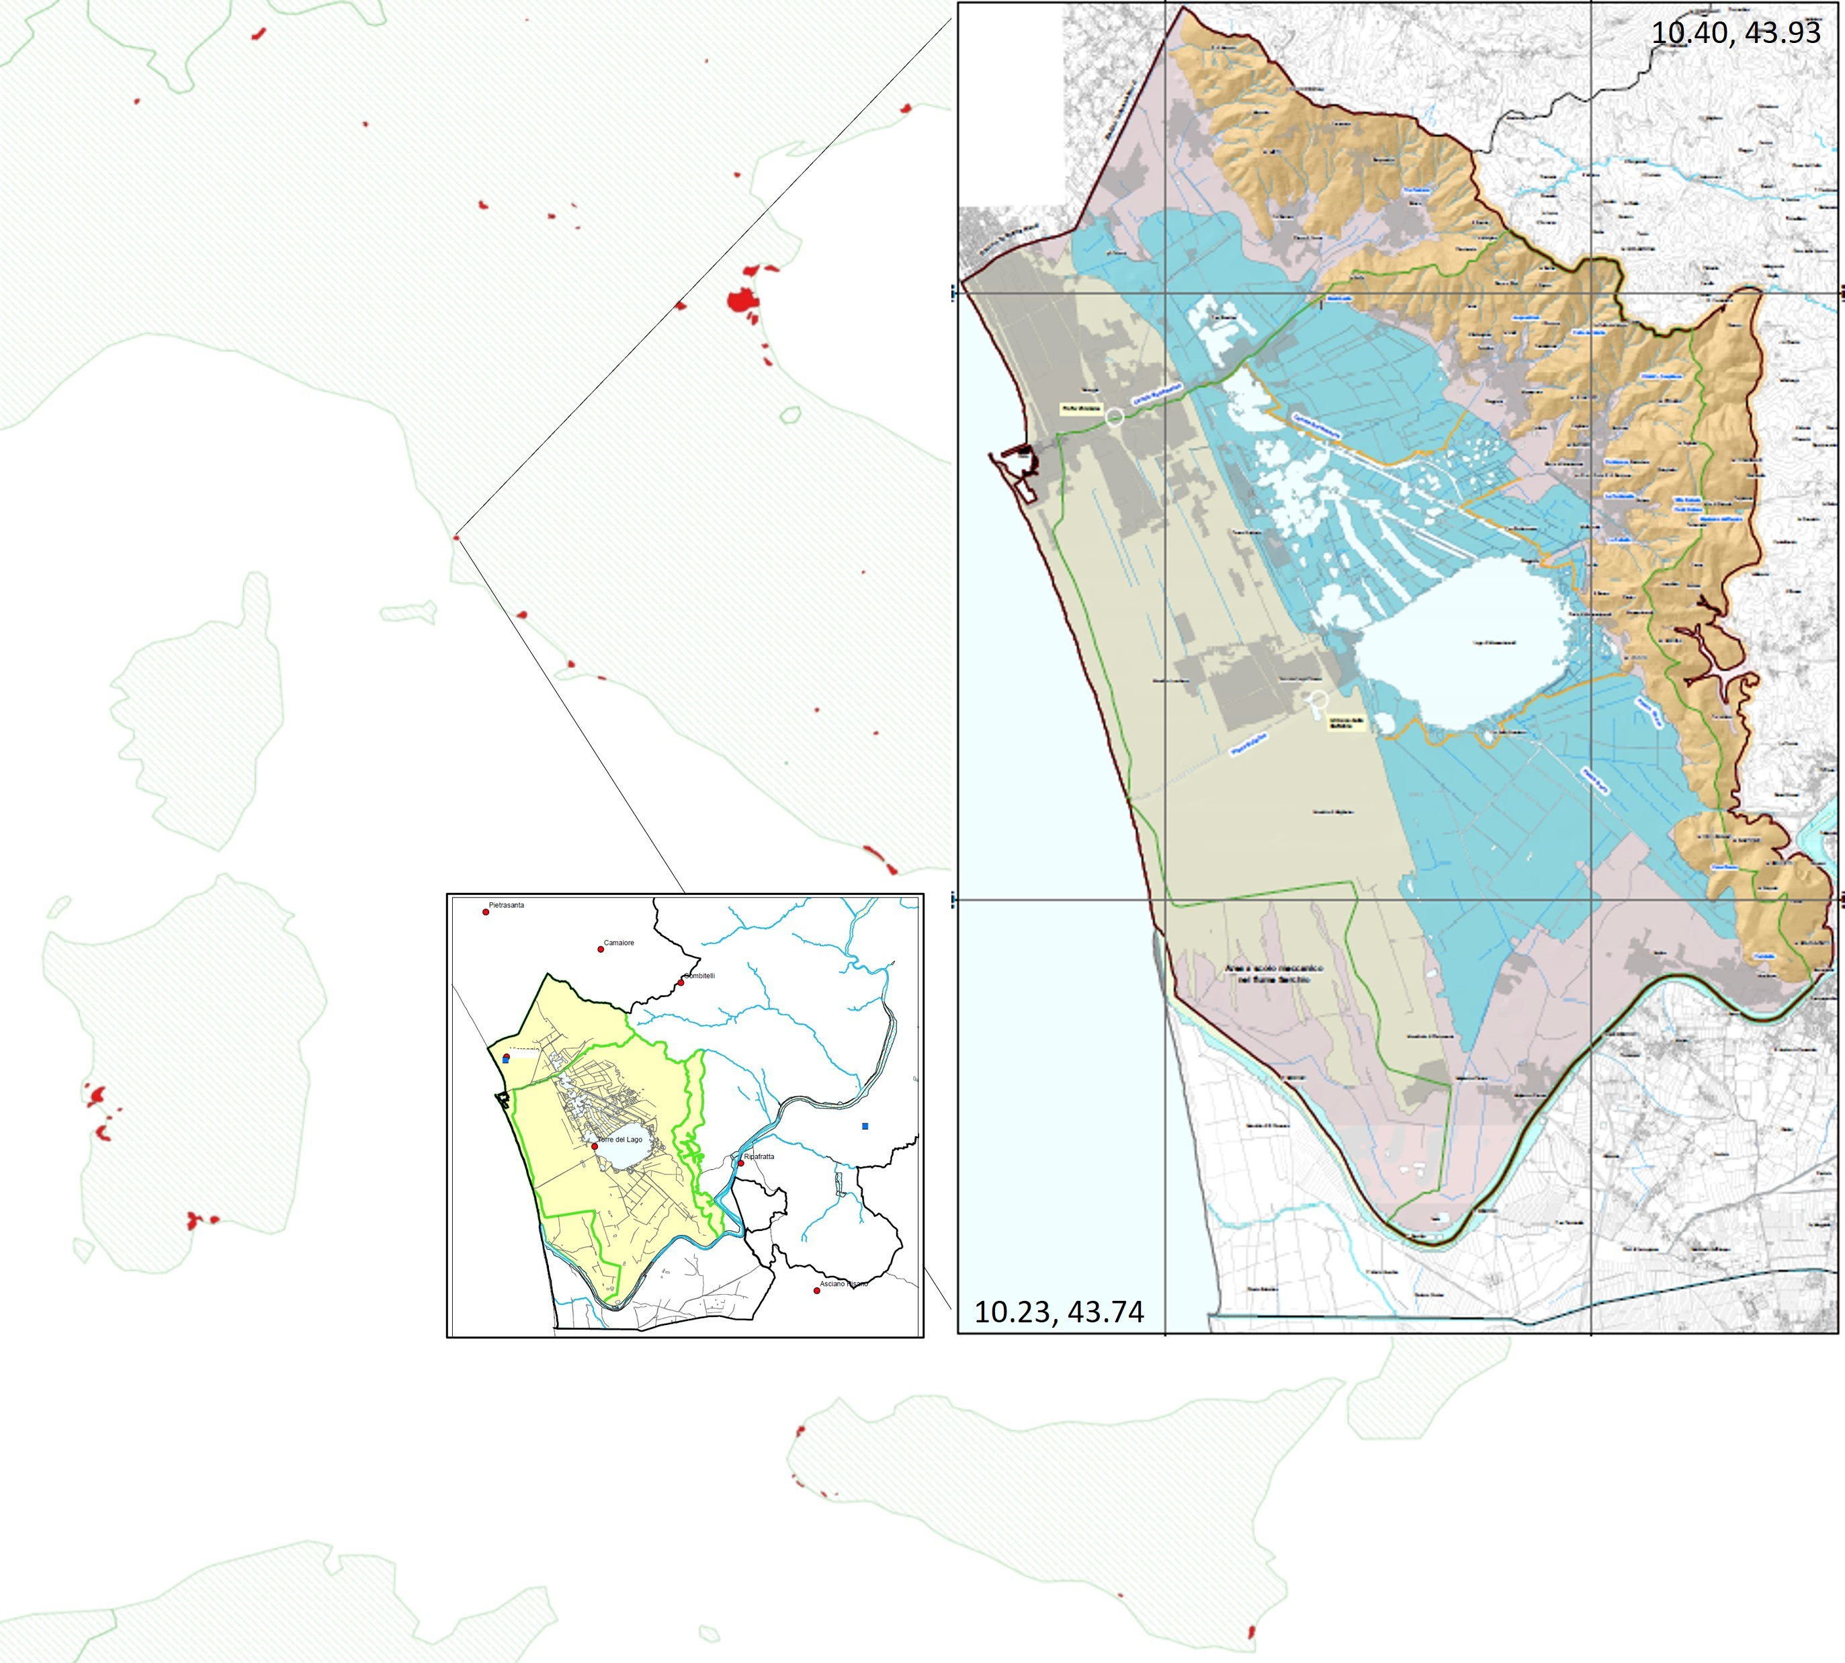

Figure S1. Geographic references of the basin of the Massaciuccoli Lake in Tuscany (Italy), with an overview (smaller image) of the river network intersecting the basin and the longitude/latitude indications of the bounding box corners. The framed images were extracted from the public maps distributed by the District Basin Authority of the northern Appennines.

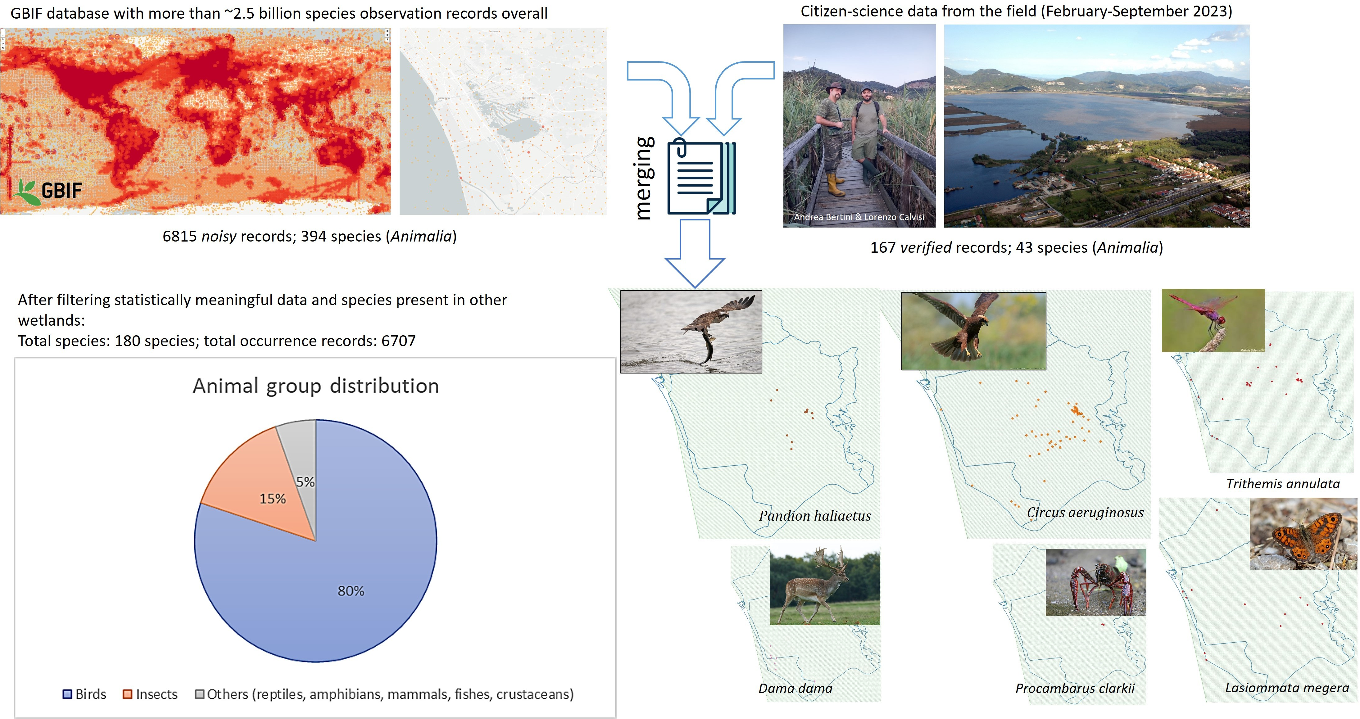

Figure S2. Schema of our species observation data-collection process. Data from GBIF and citizen observations were merged and double-checked for errors and consistency through statistical analysis. The pie chart reports the distribution of the species associated to the observations over different animal groups.

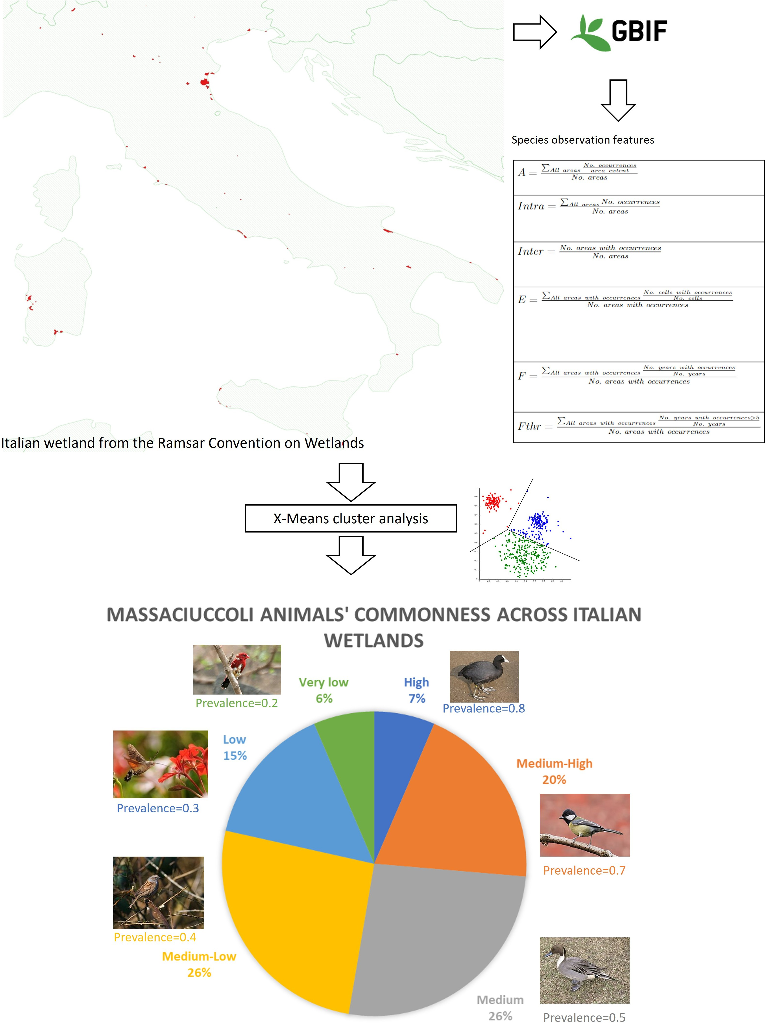

Figure S3. Schema of our species prevalence assessment process: GBIF observations falling in the Ramsar Convention-defined wetland areas of Italy were processed by extracting nu-meric features related to species commonness. X-Means cluster analysis identified classes of species commonness to which we assigned a prevalence value. The pie chart reports the per-centage of species falling in each cluster, with associated pictures of cluster-representative birds.

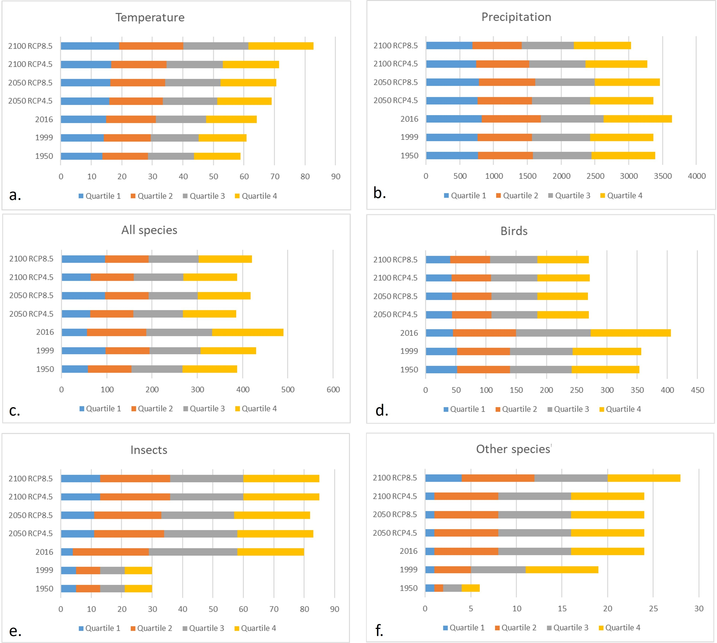

Figure S4. Piled-up quartile ranges for the estimated environmental data, i.e., Tempera-ture (a) and Precipitation (b), and the analysed species richness distribution groups, i.e., all selected animal species (c), birds (d), insects (e), and other species (reptiles, amphib-ians, mammals, fishes and crustaceans) (f).

 |  |  | Birds
 |  |  | Similarity (%)
 | 1999 | 2016 | 2050 RCP4.5 | 2050 RCP8.5 | 2100 RCP4.5 | 2100 RCP8.5
1950 | 97.5 | 64.5 | 58.5 | 57.3 | 58.8 | 57.2
1999 |  | 64.9 | 57.8 | 56.7 | 58.1 | 56.6
2016 |  |  | 26.5 | 25.3 | 26.7 | 25.2
2050 RCP4.5 |  |  |  | 98.5 | 97.1 | 98.6
2050 RCP8.5 |  |  |  |  | 98.2 | 99.8
2100 RCP4.5 |  |  |  |  |  | 98.4
Agreement (Landis & Koch, 1977)
1999 2016 2050 RCP4.5 2050 RCP8.5 2100 RCP4.5 2100 RCP8.5
1950 Almost perfect Fair Slight Slight Slight Slight

1999
2016
2050 RCP4.5
2050 RCP8.5
2100 RCP4.5
Fair Slight Slight Slight Slight Slight Slight
Poor Poor
Poor
Slight Slight Poor Poor poor

Trend
1999 2016 2050 RCP4.5 2050 RCP8.5 2100 RCP4.5 2100 RCP8.5

1950 expansion expansion contraction contraction contraction contraction
expansion contraction contraction contraction
contraction contraction contraction
contraction expansion
expansion

1999
2016
2050 RCP4.5
2050 RCP8.5
2100 RCP4.5

contraction contraction contraction contraction contraction

Growth (%)
1999 2016 2050 RCP4.5 2050 RCP8.5 2100 RCP4.5 2100 RCP8.5
1950 1.5 74.8 -96.9 -99.6 -96.3 -99.9

1999
2016
2050 RCP4.5
2050 RCP8.5
2100 RCP4.5
72.1 -97.0 -99.6 -96.3
-98.3 -99.8 -97.9
-87.8 22.4
903.3
-99.9
-99.9
-96.4
-70.3
-97.0

Insects
Similarity (%)

 | 1999 | 2016 | 2050 RCP4.5 | 2050 RCP8.5 | 2100 RCP4.5 | 2100 RCP8.5
1950 | 100.0 | 26.9 | 3.8 | 4.0 | 3.5 | 2.7
1999 |  | 26.9 | 3.8 | 4.0 | 3.5 | 2.7
2016 |  |  | 76.7 | 77.0 | 76.4 | 75.8
2050 RCP4.5 |  |  |  | 99.6 | 99.5 | 98.9
2050 RCP8.5 |  |  |  |  | 99.3 | 98.7
2100 RCP4.5 |  |  |  |  |  | 99.0
Agreement (Landis & Koch, 1977)
1999 2016 2050 RCP4.5 2050 RCP8.5 2100 RCP4.5 2100 RCP8.5
1950 Almost perfect Slight Slight Slight Slight Slight

1999
2016
2050 RCP4.5
2050 RCP8.5
2100 RCP4.5
Slight Slight Slight Slight
Slight Slight Slight
Almost perfect Almost perfect
Almost perfect
Slight Slight
Almost perfect Substantial Almost perfect

Trend
1999 2016 2050 RCP4.5 2050 RCP8.5 2100 RCP4.5 2100 RCP8.5

1950 stationary expansion expansion expansion expansion expansion
expansion expansion expansion expansion
expansion expansion expansion
contraction expansion
expansion

1999
2016
2050 RCP4.5
2050 RCP8.5
2100 RCP4.5

expansion expansion expansion expansion expansion

Growth (%)

1950 | - | 1999 | - | 2016 | 2050 RCP4.5  - | 2050 RCP8.5  - | 2100 RCP4.5  - | 2100 RCP8.5  -
1999 |  |  | - |  | - | - | - | -
2016 |  |  |  |  | 31.6 | 31.3 | 32.1 | 33.2
2050 RCP4.5 |  |  |  |  |  | -0.2 | 0.3 | 1.2
2050 RCP8.5 |  |  |  |  |  |  | 0.6 | 1.4
2100 RCP4.5 |  |  |  |  |  |  |  | 0.8

study.
Similarity (%)
Other species (fishes, mammals, crustaceans, reptiles, amphibians)

 | 1999 | 2016 | 2050 RCP4.5 | 2050 RCP8.5 | 2100 RCP4.5 | 2100 RCP8.5
1950 | 99.5 | 25.8 | 2.2 | 2.4 | 2.0 | 0.5
1999 |  | 26.3 | 2.7 | 2.9 | 2.5 | 0.9
2016 |  |  | 76.4 | 76.6 | 76.2 | 74.7
2050 RCP4.5 |  |  |  | 99.8 | 99.8 | 98.3
2050 RCP8.5 |  |  |  |  | 99.6 | 98.1
2100 RCP4.5 |  |  |  |  |  | 98.5
Agreement (Landis & Koch, 1977)
1999 2016 2050 RCP4.5 2050 RCP8.5 2100 RCP4.5 2100 RCP8.5
1950 Slight Slight Slight Slight Slight Slight

1999
2016
2050 RCP4.5
2050 RCP8.5
2100 RCP4.5
Slight Slight Slight Slight
Poor Slight Slight
Almost perfect Almost perfect
Almost perfect
Slight Slight Fair Fair Fair

 |  |  | Trend
 | 1999 | 2016 | 2050 RCP4.5 | 2050 RCP8.5 | 2100 RCP4.5 | 2100 RCP8.5
1950 | expansion | expansion | expansion | expansion | expansion | expansion
1999 |  | expansion | expansion | expansion | expansion | expansion
2016 |  |  | expansion | expansion | expansion | expansion
2050 RCP4.5 |  |  |  | contraction | expansion | expansion
2050 RCP8.5 |  |  |  |  | expansion | expansion
2100 RCP4.5 |  |  |  |  |  | expansion
Growth (%)

1950.0 | - | 1999 | - | 2016 | 2050 RCP4.5  - | 2050 RCP8.5  - | 2100 RCP4.5  - | 2100 RCP8.5  -
1999.0 |  |  | - |  | - | - | - | -
2016.0 |  |  |  |  | 31.8 | 31.5 | 32.1 | 34.1
2050 RCP4.5 |  |  |  |  |  | -0.2 | 0.2 | 1.8
2050 RCP8.5 |  |  |  |  |  |  | 0.5 | 2.0
2100 RCP4.5 |  |  |  |  |  |  |  | 1.5

